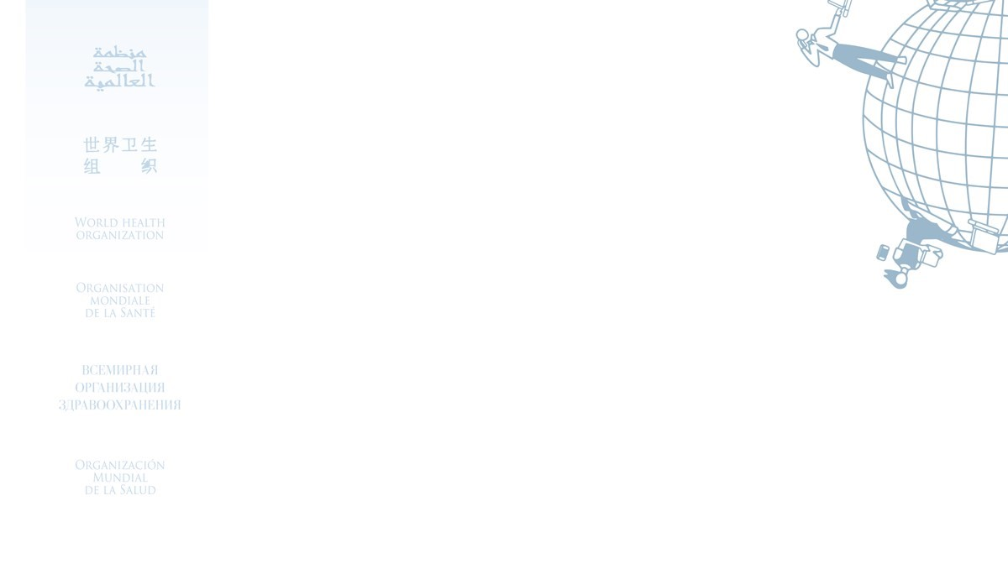

Certificate for the

**Prevention of sexual exploitation and abuse (PSEA) -**

**Multilanguage (2021)**

Awarded to

Abdul Ghafoor Khan

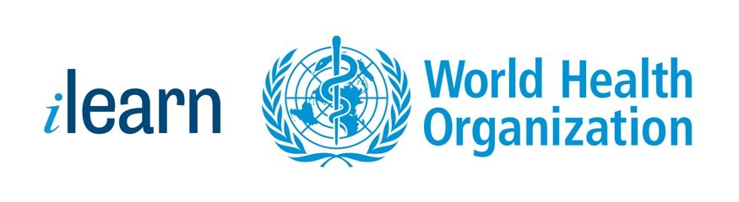

17/02/2022

Date