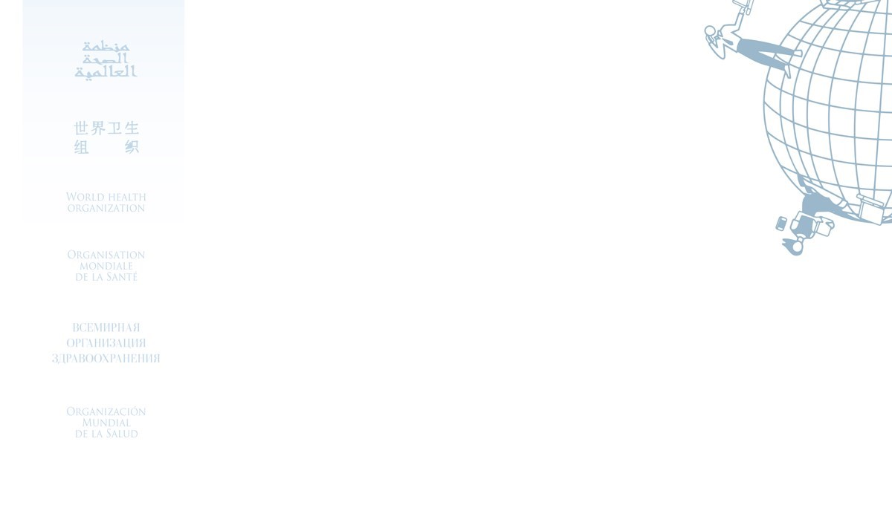

Certificate for the

**UN BSAFE (Multilingual 2022)**

Awarded to

Tahira Naz

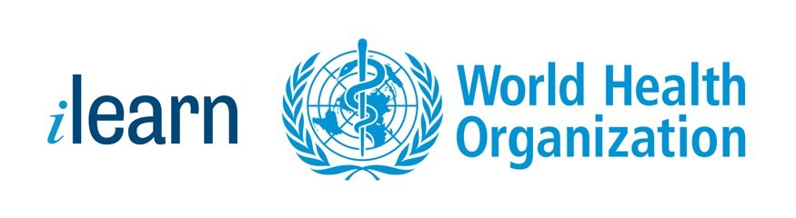

15/07/2023

Date