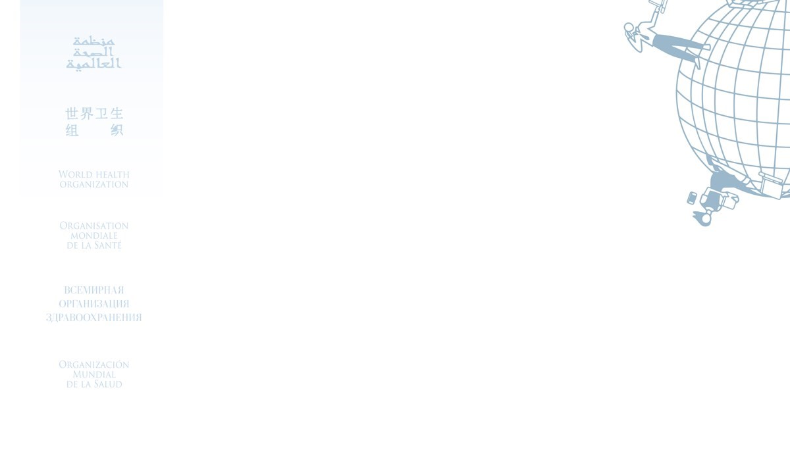

Certificate for the

**United to Respect: Preventing sexual harassment and**

**Other prohibited conduct**

Awarded to

*Tahira Naz*

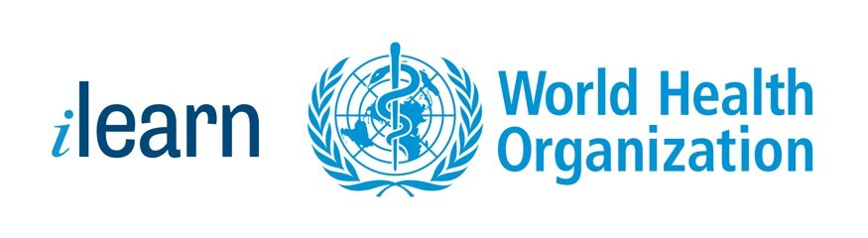

17/07/2023

Date