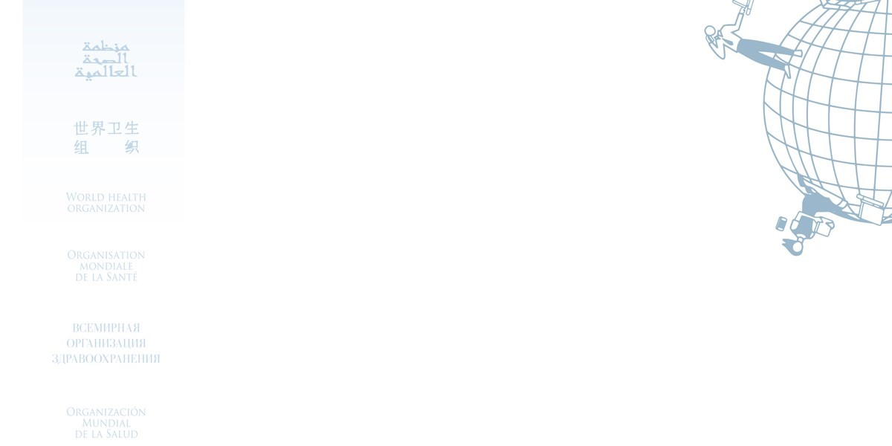

Certificate for the

**UN BSAFE (Multilingual 2022)**

Awarded to

Mohammad Diyar

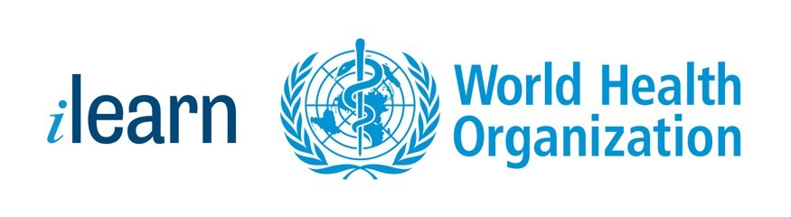

02/10/2023

Date