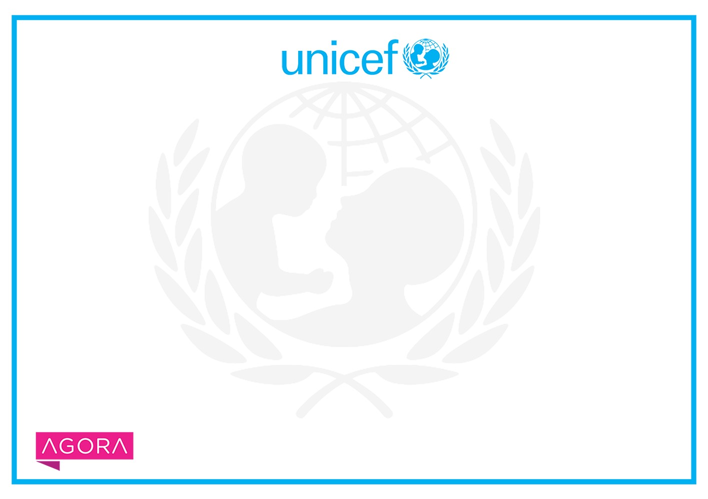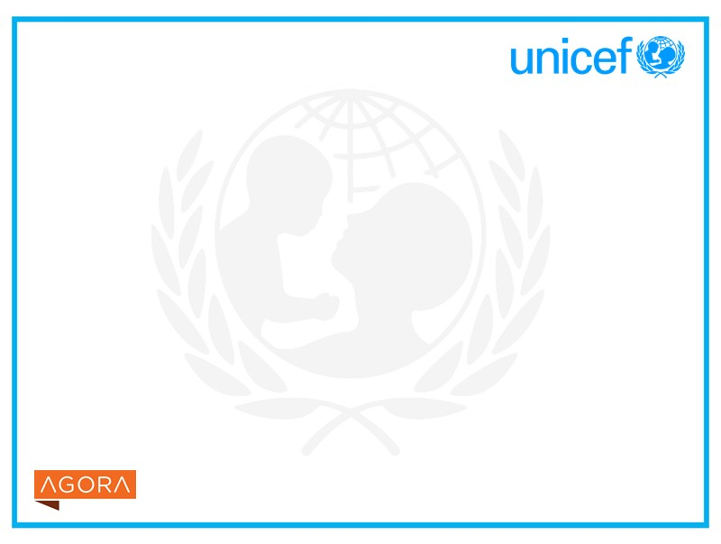

***Certificate of Completion***

Mohammad Diyar

**has successfully completed**

**Prevention of sexual exploitation and abuse (PSEA)**

Note: This certificate is issued by UNICEF through the Agora platform. It may not be recognized by other institutions – including third

party vendors or universities from which content may be offered in this course or programme.

**by**

UNICEF

**October 12, 2020**

_______________________________________

**Ian Thorpe**

**Chief of Learning and Knowledge Exchange,**

**Division of Data, Analytics, Planning and Monitoring, UNICEF**

l3ZdbDMrEN

Powered by TCPDF (www.tcpdf.org

[)](http://www.tcpdf.org/)