Professional Reference Check
Name of the person for which reference is provided : Ameen Ullah |  | Organization of referee: Secours Islamique France
Name of Referee:  Mir Ahmed Sami |  | Date of Reference:  4th March, 2024
Designation of Referee:  Program Manager |  | 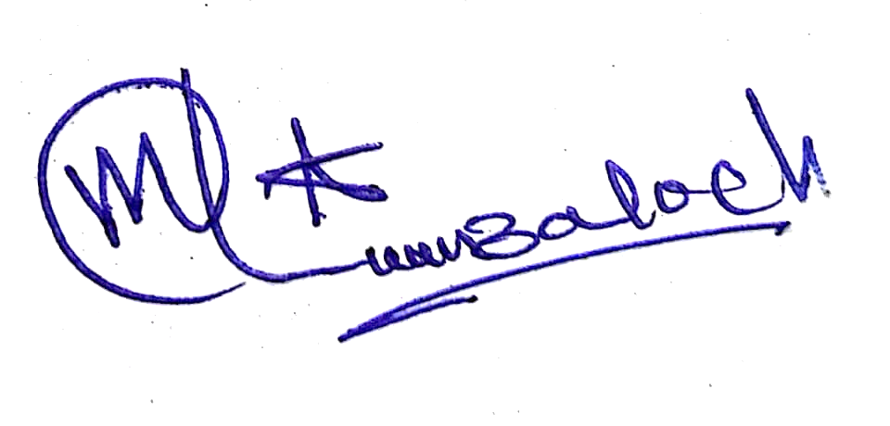  Signature of Referee

Please complete the sections below and return the filled and signed reference form to the Human Resource Department of CHIP Training and Consulting via email or surface mail (victor.john@chipconsulting.org) or CTC House 1, Street 9, G.8.2, Islamabad, Pakistan.

Tick the mentioned rating for the recommended person:
Professional/personal qualities | Out-Standing | Above  Satisfactory | Satisfactory | Not  Satisfactory | Unknown
Quality of work |  | √
Ability to work with others | √
Flexibility/adaptability to change |  | √
Punctuality |  |  | √
Communication-oral/written |  | √
Attitude | √
Judgment |  | √
Initiative/Leadership |  | √
Achievements |  | √
Overall Performance |  | √

In addition, please provide the requested information below:
- I have known the applicant
As supervisor: Project Officer Other (Please specify)--------------------------
- What was the applicant’s position in your organisation?
Cash Disbursement Facilitator
- Was there any harassment or unprofessional misconduct conduct (Sexual exploitation, sexual abuse or sexual harassment) complaint lodged against the employees by the public or other employees during the period of employment?
Yes--------------No---------
- If the answer to question 3 is positive, please explain the nature and outcome.
Sexual Exploitation-------Sexual Harassment--------Sexual Abuse------------
- Was the person engaged in any professional misconduct that may pose a risk to the safety of children and vulnerable groups/adults?
Yes--------------No---------
- If the answer to question 5 is positive, please explain the nature and outcome.
Sexual Exploitation-------Sexual Harassment--------Sexual Abuse------------
- Has any disciplinary action or investigation been taken against the person
Yes--------------No---------
- Would you re-hire him/her if a vacancy existed in your organization
Yes--------------No---------
- Would you recommend the applicant for this position?
Yes--------------No---------

