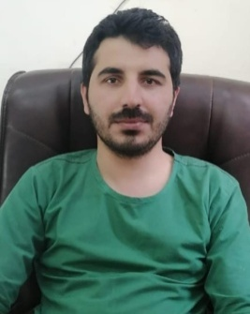
Dr.Saeed Anwar
Registered Medical Practioner
Registration No. 34536-N
S/o Sham Sher Ullah
  PERSONAL  INFORMATION | P/O Teh & Village Dosali Disttrict North Waziristan.
 |  0336-6846464 ,0320-1912284
 | Saeedanwarwazir9595@gmail.com
 | Date of birth: 03/05/1993 Nationality: Pakistan

OBJECTIVES: | Being a Doctor I consecrate my life to service of humanity. The health of any patient will be my first consideration. I want to practice my profession with conscience dignity and fear of God. I want to work as determinant and focused Doctor. I will continue my further studies in my field to remain up to date with the advancement in Patient’s care Insha’Allah.

WORK EXPERIENCE:

1 Year House job training at DHQ Teaching Hospital ,Kohat

Surgery and Allied (6months)
- General Surgery (3months)
- Ophthalmology (3months)

Medicine and Allied (6months)
- General Medicine (3months)
- Paediatrics + Nursery (3months)
6 Months Emergency Experience
Professional Skills Medical skills
- Diagnosis and treatment of different diseases
- Medical Procedures like,Catheterisation,Ascitic/Pleural Tap,NGIntubation,LP,
- CPR,ExchangeTransfusion,Nebulization,I/V line.
- Diagnosis and treatment of different diseases of paeds..
Surgical skills
- Pre & Post-OP management of surgical patients
- Surgical procedures like Incision &Drainage,SkinStitches,wound debridement,
- Diagnosis and treatment of various diseases of Ophthalmology.

EDUCATION:

2014-2019 | Bachelor of Medicine, Bachelor of Surgery (MBBS).
- KMU Peshawar.
- Obtained Marks 60%
2012 | Intermediate Higher secondary School certificate.
- P.P.C Boys Inter College Bannu.
- Obtained Marks 78%
2009 | Matriculation
- University Wensam College D.I Khan.
- Obtained Marks 78%

Other Achievements :
- Participated in different national Conventions & workshops
- I used to participate in almost all the extracurricular activities in school, college and university and have multiple awards of talent.
- I can also speak and write English Urdu and Pashto.

Languages :

- English.
- Urdu.
- Pashto

