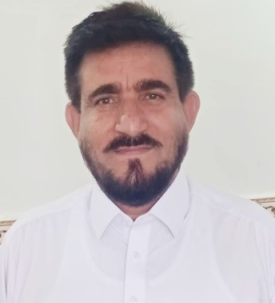

Dr.Khandat Khan
PMDC Reg.3862-N
Email:sokhandat1@yaho.com
Mobile :03339505083-03469213742

OBJECTIVE:
- To exert my skills as the best organizer in my management and professional activities.
- To play a positive role for upholding the society.
- To put my potent talent into productive competence.

PERSONAL INFORMATION:

- Father Name : Shaista Khan
- CNIC : 21501-6097207-7
- Date of Birth : 20/11/1964
- Domicile : North Waziristan
- Nationality : Pakistani
- Religion : Islam
- Marital Status : Married
- Address : Village Syed Abad Tarka khel p/o Boya Tehsil Datta khel . Subdivision Miranshah District North Waziristan.

ACADEMIC QUALIFICATION:

Degree’s | Year | Marks | Board /University
SSC | 1979 | 473/850 | BISE Peshawar
FSc | 1981 | 502/1050 | BISE Peshawar
MBBS | 1986 | 959/1700 | AMC Abbott Abad

EXPERIENCE:

- House job in medicine LRH Peshawar six months.
- House Job in surgery Saidu Shareef Swat six months.
- Medical Officer from 29 November 1995 upto March 2008 DHQ Miranshah North Waziristan.
- Surveillance officer (WHO) from March 2008 to July 2011 in North Waziristan.
- poleo Eradication Officer (WHO) from July 2011 upto Dec 2020 in North Waziristan

LANGUAGE SKILLS :

Language | Speaking | Reading | Writing
Pushto | Excellent | Excellent | Excellent
Urdu | Excellent | Excellent | Excellent
English | Good | Excellent | Excellent

COMPUTER SKILLS :

- MS Word, Excel, PowerPoint.

