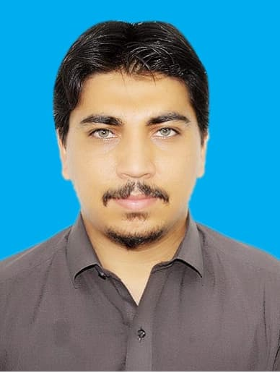 |  | DR. NADAULLAH  PMC Reg No # 719570-03-M
Profile  Seeking a job in the field of medical profession to prove my abilities for my professional care of people in a challenging environment. Possess the capabilities of doing chilling assignments and hard work. I am willing to work is a key player in a challenging and creating environment to contribute towards the growth of organization/institution  Personal information  Father Name: Muhammad Din  Nationality: Pakistan  Religion: Islam  Domicile: District North Waziristan  Date of Birth: 25-12-1996  Contact  PHONE:  +92-3478976752  Address:  District North Waziristan  Tehsil Mir Ali  EMAIL  Drnadaullah@gmail.com  Hobbies  - Reading Book  - Sports |  | EDUCATION  MBBS  Marks: (70%)  Khyber Medical College Peshawar  2015-2020  FSc (Pre Medical)  Marks: (82 %)  BISEP Islamia college peshawar  2014  Matric  Marks: (86%)  BISE Bannu  2012  National Licensing Exam  Passed December, 2021  Pakistan Medical council  WORK EXPERIENCE  Lady Reading Hospital (House Officer)  (1st July, 2021 to 30th June, 2022)  SKILLS  ENT:  - Management of epistaxis  - Management of otitis media,ome, pharyngitis & sinusitis  - Dressing & Debridement of wounds  - Stitching & their Removal  - F.B removal from nose & ear  - Fish bone removal from throat  - Pre-op and Post-op Patient Management  - NG Tube  - Assists tracheotomy  - Catheterization

General Surgery:
- Appendectomy done under observation
- Abscess I/D
- Management of Acute emergencies like RTA, HOF& Stab wounds
- Dressing & Debridement of wounds
- Stitching & their Removal
- IGTN
- Assisst exploratory laparatomy
- Pre-op and Post-op Patient Management
Medicine:

- Blood Sampling & I/V line
- Ascitic Tap
- Pleural Tap
- NG Tube Passing
- Catheterization
- Nebulization in Respiratory Patients
- Lumbar puncture for CSF aspiration
- CPR in Critical Patients
- Command on ECG performing and reading
- Command on Management of Medical Emergencies
- Common OPD prescription
Endicrinology:

- Management of uncontrolled blood sugar.
- Management of DKA
- Blood Sampling & I/V lin
- Patients and attendants counseling
- Diabetes patients screening
LANGUAGES

- English, Urdu, Pashto

COMPUTER SKILLS:

- Office Automation
- Internet

