**DR. RIAZ AHMAD  
Father Name: SIRAJ UD DIN  
 Date of Birth: 5th January,1994  
National ID Card Number: 21708-9759942-5  
Current Address: Village Doag, South Waziristan, Khyber Pakhtunkhwa.   
Cell/Whatsapp: 0336-1965735/ 0334-0946165  
Email Address:** [**dr.riazahmad2020@yahoo.com**](mailto:dr.riazahmad2020@yahoo.com)

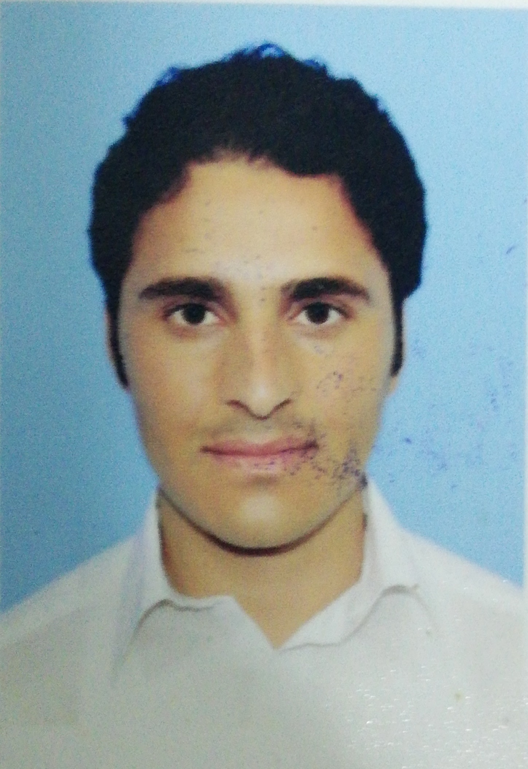

**CAREER OBJECTIVE:**-To stand out and excel in my service to a dynamic organization, so that I become their pride.  
-To enhance my skills and knowledge working as a responsible person in any company. **QUALIFICATION:**-Matriculation (10th Class): New Iqra Public High School Wana, South Waziristan Agency.-Intermediate (12th Class): Peshawar Public School and College, Peshawar.-MBBS: Jinnah Medical College, Peshawar. **(Affiliated with Khyber Medical University)  
OTHER SKILLS:**-Computer knowledge; MS Word, Power Point, Web Browsing etc.  
-Leadership skills gained from academic background along with debates, speeches and presentations.   
-Communication skills with the ability of working with multi-cultural and multi-disciplinary teams.  
-Good analytical and problem solving skills; working both independently and in a group.  
-Self-confident and hardworking nature.  
  
**PERSONAL EXPERIENCE:**-Worked in medical wards and clinics for the sake of experience after acquiring NOC from college.  
-Volunteered in some events around the city.  
-Have remained as a medical tutor in college for the junior students.

**HOUSE JOB:**

**DHQ Charsadda Teaching Hospital**

* Medicine & Allied (3 months)
* Surgery & Allied (3 months)
* Paediatrics (3 months)
* Emergency (3 months)

**Lady Reading Hospital Peshawar**

* 3 months MOship in the Cardiology Ward

**Jinnah Teaching Hospital Peshawar**

* 1 year MOship in Emergency Department

**LANGUAGES:  
English** (fluently), **Urdu** (fluently) & **Pashto** (fluently).  
**References of the above given details will be furnished on demand.**