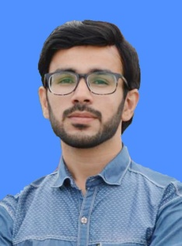
Resume

Dr.Dawood Jan
Postal address ; Mohala Baro Khel , P/O Sardheri Tehsil & Distt Charsadda
KPK, Pakistan
Cell No.0315-5949414 0341-7222734
Email: dawood3974@gmail.com

OBJECTIVE

- Seeking a challenging position in any dynamic organization to get more
exposure and growth opportunities and to enhance skill and knowledge.
- To play the positive and active role for upholding the society and the related individuals.

PERSONAL INFORMATION

- Father’s Name : Shah jehan
- Date of Birth : 15/12/1997
- C.N.I.C : 17101-6793201-9
- Domicile : Charsadda
- Nationality : Pakistani
- Religion : Islam
- PMC Reg No : 718107-03-M
ACADEMIC QUALIFICATION

Degree | Year | Subjects | Div | Board/University
S.S.C | 2013 | Science | 1st | B.I.S.E Peshawar
H.S.S.C | 2015 | Pre-Medical | 1st | B.I.S.E Peshawar
M.B.B.S | 2021 | Medicine and Allied  Surgery and Allied | 1st | KMU Peshawar

Language Skills.
English, Urdu, Pashto,
Professional Experience.
1 year full residential & paid house job in KGN Teaching Hospital,Bannu.
Medicine (6 months)
- General medicine 3 months.
- Peads medicine 3 month.
Medical Skills:
- Daigonosis & treatment of diffirent diseases, medical procedures like catheterization, NG intubition, pleural tap, ascitic tap, IV line, LP, pericardial paracentesis etc.
- Accident & Emergency management 06 months.
Surgery (6 months)
- General surgery 3 months.
- Neuro surgery 3 months.
Surgical Skills:
- Daigonosis & treatment of diffirent diseases, surgical procedure like appendectomy, incision & drainage, wound debridement, dressing, nasal packing, suprapubic cathaterization, closed reduction, Skin & Skeletal traction and cast application etc.
Hobbies:
- Playing Cricket, Volleyball, Reading books, newspapers, Poetry
References.
Reference will be provided on demand.

