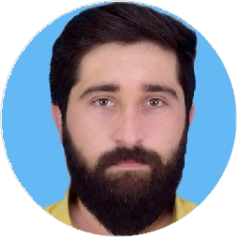

Rahim Ullah Khan

Medical Doctor, MBBS, PMC Registration No. 719252-03-M

Responsible physician with 1 year of experience maximizing patient wellness and facility proﬁtability. Seeking to deliver healthcare excellence at Hayatabad Medical complex .



[rahimullah2481@gmail.com](mailto:rahimullah2481@gmail.com)

03415693661

# SKILLS

IV Cannulation

ABGS

NG tube

proctoscopy

**EDUCATION**

## Bachelor of medicine and Bachelor of surgery

### Khyber Medical College, Peshawar

*2015 - 2021*,

## FSC

### (CADET COLLEGE RAZMAK)

*2013 - 2015*,

## HSSC

### (CADET COLLEGE RAZMAK)

*2013*,

back slab plaster

# WORK EXPERIENCE

POP

catheterization

## House Oﬃcer

DRE

ECG

### Hayatabad Medical Complex

ascitic tap

*06/2021 - 06/2022*, *Tertiary Care Hospital*

*Achievements/Tasks*

plueral tap

ACLS

attending daily rounds, active management of ward patients, attending Emergencies, managing outpatient clinic

BLS

thoroughly examined patients took medical history for assessing health and identifying health condition of patients

venous sampling

collected basic samples, labelled specimens properly and transferred to laboratory for testing administered basic wound care

incision, drainage and debridement

CPR

stitching

Skill

# LANGUAGES

Pashto, Urdu and English

*Full Professional Proﬁciency*

# INTERESTS

**HOUSE JOB ROTATIONS**

General surgery (3 months) General Medicine (3moths) orthopedics (3 months)

Pediatrics (3 months)

# ACHIEVEMENTS

Occupational English Testing passed National Licensing Exam passed Preparing for PLAB

football, table tennis

cricket

Interest