Kashif Ullah Khan  Cell No:00923344647229  Mohalla hajjiyan,village dagbehsud, PO pabbi district Nowshera KPK  Email: kashikhan93@gmail.com | 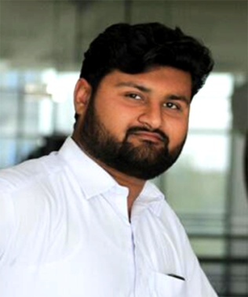
Career Objectives

- To contribute towards the growth and development of a dynamic organization having opportunities for both personal and professional growth, where I can add value to the work environment together with achieving goals and targets both for self-contentment and for the organization.
- To pursue a challenging position in a reputable and futuristic organization and prove my skills and competencies by contributing to the organizational success.

Executive Profile

- Ability to learn new tasks and ideas quickly.
- Practical exposure of working with seniors and middle management.
- Good communication and interpersonal skills.
- Ability of adjust and work in team environment.
- Ability to work under pressure.

Professional Experience

Store Assistant at Khyber Tobacco company Mardan December 2015 to August 2016

  - Receiving and issuance of material.
  - Record maintenance
  - Preparation of MRN

TTM (Temporary Tehsil Monitor) August 2016 to January 2019

- Conducting UPEC meeting and team trainings for polio campaign.
- Ensure 100% micro plans desk revision and field validation
- Ensure 100% trained team members above 18 Yrs.
- Assist in monitoring of timely distribution of DDM Cards.
- Tally sheet analysis of the (during process) campaign.
- Monitoring and Supervision of all “AIC and Team” training sessions and report submission to PEO, PDA.
- To maintain all pre-record in Health facility in the folder.
- Monitoring report consisting of team deployment, vaccine status and presence of must members.

UCPO (Union Council Polio Officer) at chip training and consulting at WHO project January 2019 to march 2021.

- Conducting UPEC meeting and team trainings for polio campaign.
- Ensure 100% micro plans desk revision and field validation
- Ensure 100% trained team members above 18 Yrs.
- Assist in monitoring of timely distribution of DDM Cards.
- Tally sheet analysis of the (during process) campaign.
- Monitoring and Supervision of all “AIC and Team” training sessions and report submission to PEO, PDA.
- To maintain all pre-record in Health facility in the folder.
- Monitoring report consisting of team deployment, vaccine status and presence of must members.
- Conduct post campaign assessment in union council.
- Miss Children follow-up.
- Zero Dose Verification.
- Support and facilitate Routine Immunization outreach sessions.

Time keeper at AS CONSTRUCTORS(Private) LIMITED August 2021 till Now

- Maintaining Attendance Record
- Making Wages Report (Computerized+ Manual)
- Maintain Labor Wastage

Academic Record

- MBA 1.5 (Humane ressources) City University of science and information tech Peshawar
- BBA(hons) (marketing) Abdul Wali Khan University Mardan
- Fsc (pre engineering) BISE Mardan
- Matric (Science Group) B.I.S.E Mardan

Computer Skills
Proficient in MS-office, internet surfing and e-mail applications.

Personal Information
- Father Name Sher bahadar khan
- Date of birth 21st feb, 1993
- Marital status married
- Religion Islam
- Nationality Pakistan

Languages
- English Conversational
- Urdu Conversational
- Pashto Conversational
- Punjabi Conversational-Limited

Hobbies & Interests
- Sports such as cricket.
- Travelling.
- Surfing the Internet.
- Riding motorbikes.
Attributes

- Good listene,Solid work ethic,Desire to excel,Meet deadline,Enjoy fast paced working environment extraordinary factual recall…
- I'd love to find out more about the position you're looking to fill, and I would welcome the opportunity to tell you how my skills and ideas can benefit for your organization.
- You will benefit from my outstanding abilities and capabilities. I possess high energy level of hardworking and honesty.
- I am positive a personal interview would more accurately reveal my qualifications and the contribution I can make towards your organization’s success.

References
Reference will be provided on spot if necessary.

