**IJAZ UL HAQ**

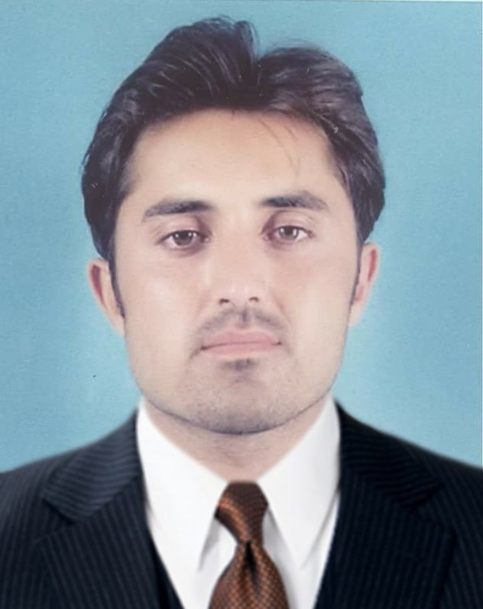

**Personal Particulars**

Father Name: Roshan Zamir

Date of Birth: 5th January 1987

Nationality: Pakistani

Place of Birth: **Village Shagai,P.O Box & Tehsil Jarmrud, District Khyber Agency, FATA**

Domicile: FATA

C.N.I.C #: 21202-9787220-5

Religion: Islam

Postal Address: Village Shagai Lalachina, Tehsil & P.O Jamrud, District Khyber.

E-mail: ijazbrnn@gmail.com

Contact No: 0345 9035979 0332 5807339

Gender: Male

Marital Status: Married

**Qualification**

2012 – 2014 **MBA (FINANCE)**

***University of Peshawar*,**

1st Division

2009 – 2011 **Bachelor (arts)**

***University of Peshawar*,**

2nd Division

2004 – 2006 **intermediate (arts)**

***Board of intermediate and secondary education Peshawar***

2nd division

2001 – 2003 **S.S.C (Science**)

***Board of intermediate and secondary education Peshawar***

2nd division

**Computer Skill**

|  |  |  |
| --- | --- | --- |
| **S. No** | **Name** | **Level** |
|  | Diploma in Information Technology (DIT) | Intermediate |
|  | Peachtree, Quick book, Tally | Intermediate |
|  | MS OFFICE | Expert |
|  | Computer Networking | Intermediate |

**Languages:**

|  |  |
| --- | --- |
| **S. No** | **Language** |
|  | English |
|  | Urdu |
|  | Pashto |