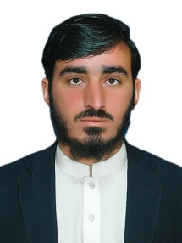Curriculum Vitae

*Mailing &Permanent Address*

*Tehsil Jamrud Ali Masjid*

*District Khyber*

*Contact # 0300-5022038*

**PERSONAL BIO-DATA:**

|  |  |  |
| --- | --- | --- |
| Name | **:** | **Naseer Ahmad** |
| Father’s Name | **:** | Nasrat Ullah |
| Date of Birth | **:** | 22-06-1999 |
| Nationality | **:** | Pakistani |
| N.I.C. No. | **:** | 21202-3399999-5 |
| Domicile | **:** | Khyber Agency |
| Religion | **:** | Islam |
| Marital Status | **:** | Married |

**ACADEMIC RECORD**

|  |  |
| --- | --- |
| ***Qualification*** | ***Board/university*** |
| Metric | Peshawar board |
| F.SC(Pre Eng) | Peshawar board |
| B.S physics | University of Peshawar |

**HOBBIES**

❖ Reading books and newspaper, Playing Games.

**EXPERIENCE**

* Two Years Experience as a Teacher at Ghalani Children Academy.
* Two Years Experience in photostate and Printing Center

**ACADEMIC QUALIFICATION:**

|  |  |  |  |  |  |
| --- | --- | --- | --- | --- | --- |
| Exam | University / Board | **Passing Year** | **Division** | **Marks** | **Percentage** |
| S.S.C | BISE Peshawar | 2015 | 1st | 865 | 78 % |
| F.Sc. | BISE Peshawar | 2017 | 1st | 673 | 62 % |
| B.S | PeshawarUniversity | 2017-21 | 1st | 3.48 Cgpa | 81 % |
| DIT | KPBIT Peshawar | 2018 | 1st | 1130 | 80% |

**LANGUAGES:**

* English
* Urdu
* Pushto