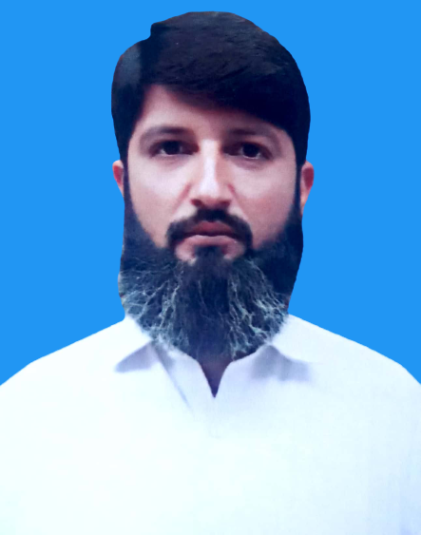
Curriculum Vitae

SADAQAT HAROON
Contact No. 0333-9644156

Objective:
To become an efficient employee of an international / National, Dynamic & Progressive organization environment in order to enhance core competencies, where I can contribute positively & can use my academic & professional knowledge for the success of my job.

PERSONAL Profile
Fathers Name : Misal Jan
Date of Birth : 08-12-1988
Domicile : Karak
C.N.I.C : 14301-8332135-5
Religion : Islam
Nationality : Pakistani
Marital Status : Married
Gender : Male
Contact Address : House # 158 Sector D 3 KDA Kohat
E-mail Address : sadaqat.haroon@gmail.com

EDUCATIONAL QUALIFICATIONS

Qualification | Year | Board / University
BS Sociology  (4 years M.sc equilent) | 2012 | Department Of Social Work & Sociology KUST Kohat
F.S c | 2007 | BISE KOHAT
S.S.C | 2005 | BISE KOHAT

TECHNICAL COURSES
- 2 years Diploma in Health Technology (KPK Medical Faculty).
- Diploma in information technology (TTB Peshawar).

COMPUTER PROFICIENCY
- MS Windows, MS Office (Complete), Basic Internet, Typing.
- Hardware course.

EXPERIENCE

Union Council Polio Officer in WHO.(july 2016 to Feb 2021)

Microplanning for Essential immunization and polio campaign.
- Data analysis of polio campaign and Essential immunization.
- AFP surveillance and zero reporting of different diseases.
- Monitoring and supporting of polio workers,Upecs and aics.
- Routine immunization monitoring.
- Teams trainings and house to house microsences and route maps preparation.
- Surveillance of Covid-19.

TTM in WHO.(sep 2015 to June 2016)

Microplanning for polio campaign.
- Data analysis of polio campaign.
- AFP surveillance and zero reporting of different diseases.
- Monitoring and supporting of teams of polio workers.
- Routine immunization monitoring.

Hygiene promoter (casual) in ACF International (WASH project).
- Field visits of the communities.
- Data collecting from the communities.
- Social awareness in people about hygiene practices of the communities.
- Arranged hygiene sessions & give session to the community.
- Verifying the people of the community registered with ACF in WASH project.
- Punched and managed verification data.

Social Organizer in BISP Kohat (Five months). A project with Aurat Foundation Kohat.
- Field visits of the communities.
- Data collecting from the communities.
- Dialogues with the community & build up the committees in the communities.
- Verifying the people of the community registered with Bisp.
- Punched and managed Bisp verification data.

Four Months Internship in SRSP Kohat. During internship I participated in the following activities:
- Attended and facilitated in Community Management Skill Trainings(CMSTs)
- Participated in field visits of the communities.
- Attended First Dialogues along with Social Organizers with the community.
- Punched and managed poverty score cards.

One week survey in ACF (KP iv Base Line ) FSL Project Kohat. In this survey main
Focus on:
- Food Security & Livelihood
- IDPs Focusing
- Current situation of people. House hold diety diversity & House hold Food in security (equalicy scale)
- Identification of people registered with ACF in FSL project in CFW & CCG categories.

One week survey in ACF (KP iii Base Line ) WASH Project Kohat. In this survey
main Focus on:
- Water, Sanitation And Hygiene promotion.
- IDPs Focusing
- Current situation of people. There hygienic practices, and behavior change.
- Identification of people registered with ACF in WASH project in CFW & CCG categories.

One week survey in Handicap International WASH Project Kohat. In this survey

main focus on:
- Water, Sanitation And Hygiene promotion.
- IDPs Focusing
- Current situation of people. There hygienic practices, and behavior change.
- Identification of people registered with handicap in WASH project.

LANGUAGES PROFICIENCY
- English, Urdu, Pashto

