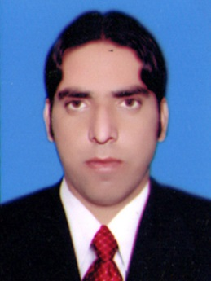Ali Muhammad

**Personal Information**

Father’s Name : Khysta Bagh

Address : Ali Masjid Jamrud District Khyber

Domicile : District Khyber

Date of Birth : 01-18-1992

Religion : Islam

Nationality : Pakistani

CNIC # : 21202-546775-9

Marital Status : Married

Contact No. : 03077183209

Email : aliafridi032@gmail.com

**Academic Qualification**

|  |  |  |  |
| --- | --- | --- | --- |
| **Certificate** | **Session** | **Board/University** | **Grade** |
| Metric | 2008 | BISEP | 1st |
| FSc | 2010 | BISEP | 1st |
| BA | 2012 | University of Peshawar | 2nd |
| MSc Economics | 2014 | Agriculture Of Peshawar | 1st |

**Diploma & Course:**

1. DIT From Technical Board Peshawar.
2. Ms Office From Brains Collage Peshawar.
3. Social Media Work from Brains Collage Peshawar.

**Experience**

1. 1 year experiencein Prime Minister Internship as a Office Assistant in Fata Education DeP
2. 1 Years’ experience in Prime Foundation Pakistan as a Team Leader.
3. 3 Years’ experience as a Social Mobilizer In WHO In Polio.
4. 1 Year experience MMP Organization as a Supervisor.
5. 6 Months experience in Prime Minister Health Card Distribution as a Computer Operator.

**Language Proficiency**

|  |  |  |  |
| --- | --- | --- | --- |
| **Language** | **Reading** | **Writing** | **Speaking** |
| Urdu | Excellent | Excellent | Excellent |
| English | Better | Better | Better |
| Pashto | Excellent | Excellent | Excellent |

**Hobbies____________________________________**

1. Cricket
2. Social Media Network (Facebook)
3. Reading Newspaper
4. Reading Books