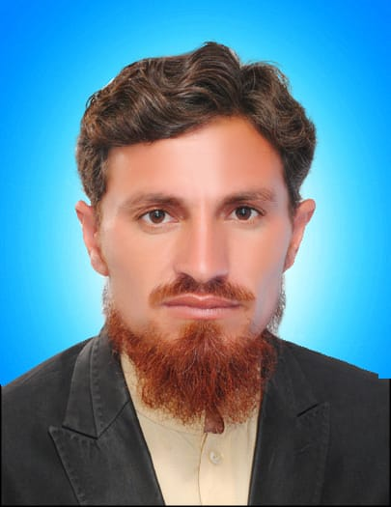**Muhammad Arif**

Village P/O Fathma, Kashmiryan District Mardan

Cell#: 03453401314

NIC: 16101-9809593-3

Email: [marif.mdn@gmail.com](mailto:marif.mdn@gmail.com)

**CAREER OBJECTIVE**

I am hard working and compassionate social worker backed by Five years of professional experience in PEI (Polio Eradication Initiative) Program; I have the skills of Planning, Operations Management, Monitoring, Data Collection & Analysis, Communication and Coordination. I am looking for an opportunity that would help me in build up my skill and enjoy my growth. I am confident that I will be able to fulfill my duties in conformity to requirement of the organization.

**EDUCATIONAL QUALIFICATIONS**

**2008-2009 M.Com** (Finance) University of Peshawar

**2007-2008 B.Com (Hons)** University of Peshawar

##### **EXPERIENCES**

**Febuary-2012:** Worked as a “***Union Council Polio Officer”***

2019 – CURRENT – Mardan/KP, Pakistan

**CHIP Training & Consulting (pvt.) Ltd. (CTC).**

2012-2019– Mardan/KP, Pakistan

**World Health Organization**

**Responsibilities:**

* Provide Technical Support to the Union Council Polio Eradication Committee on poliomyelitis eradication
* Work closely with government and partners to ensure coordination of different stakeholders in the assigned area
* Ensure the functioning of the UPEC in the assigned areas
* Support the full implementation of the National Emergency Action Plan (NEAP) and other key policy documents on polio eradication and immunization at the UC level

1. **Supplemental Polio Vaccination Campaigns (SIA)**

* Support the Union Council on ensuring all the agreed SIA timelines are followed and implemented
* Assist the UC team in motivating local, adult and females teams and AICs to be part of campaign implementation
* Facilitate and monitor the trainings of teams, AICs, and other categories of health workers involved in campaign implementation
* Carry out assigned planning meetings including micro plan preparations at the Union Council
* Support the timely distribution of logistics in the assigned Union Councils, and ensure all necessary steps are taken to ensure no delays or stock outs of logistics at the assigned areas.
* Monitor the effective utilization of mobile, fixed and transit teams in the assigned area, and immediately report misuse to the immediate supervisor
* Formulate an appropriate plan for coverage of missed children
* Work closely with the communities in the assigned areas to rebuild trust in vaccines, combat misinformation and generate demand for polio vaccination
* Mobilize religious, tribal and political leaders, and other influential persons in the assigned area to support polio eradication
* Formulate a daily priority based supervision and monitoring plans of the AICs and UC teams to ensure support to poor performing areas and motivation of teams.
* Supervise and monitor the work of the teams and AICs, take house hold clusters and at the same time validate a sample of the clusters and missed children coverage done by the UC team
* Ensure all reported missed and poorly covered areas are investigated and re-vaccination/sweeps carried out.
* Analyze the daily data and collate the observations of the UC teams and present the findings, actions and recommendations at the daily evening meetings
* Provide special focus on the high-risk populations during all the phases of the campaign in line with the special strategies devised for risk populations and the National Emergency Action Plan for Polio Eradication.
* Carry out a post campaign analysis of data and share with the UPEC and supervisor
* Follow up with respective tehsils/UCMOs in timely filling of DDM cards and submission
* Support vaccine management at the Union Council level

1. **AFP Surveillance**

* Support community surveillance by ensuring mapping and inclusion of all formal and informal health care providers in the assigned area in the AFP surveillance network
* Participate in detailed epidemiological investigations as determined by the immediate supervisor
* Assist in ensuring inclusion of all high risk/ underserved/ migrant population in the Surveillance network and all AFPs are reported from them.
* To support timely submission of “Zero Report” from assigned UCs.

1. **Routine Immunization**

* Support the strengthening of routine immunization through participation in the development of micro plans for implementation of routine immunization
* Support the UPEC in engaging and mobilizing communities RI demand creation and building the trust of communities in vaccine uptake.
* Identify zero dose and under immunized children in the assigned UCs and refer them for immunization

1. **Other activities**

* Implement any additional tasks and/or activities related to polio eradication assigned by the supervisor.

##### **Additional Experience**

##### July 2020 Training to Combat Covid-19 **NRSP**

##### Jun 2010 Internship **Askari Bank**

##### Jun 2012 Active Citizen **British Council**

##### May 2011 Election Observer **FAFEEN (IRSP)**

##### **LANGUAGES**

English, Urdu and Pashto (native language)

##### **Computer skills/Certificate**

Ms Office Complete.

**REFERENCES**

**Dr Fahad Asif**

Immunization officer

World Health Organization Mardan Division

Mobile: 03105400008

Email: Mirza.fahadasif@gmail.com