CURRICULUM VITAE

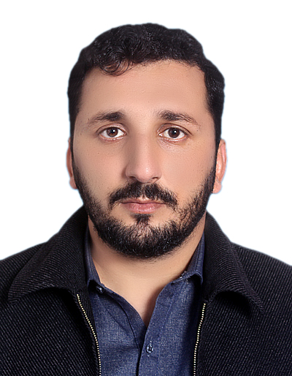

FALAK ZEB

OBJECTIVES:
Seeking a career growth position in a leading organization with an aim to contribute positively towards the achievement of organizational objectives, to develop and improve my professional skills and eventual status in the mid career management.

Address: Koki Khel Sher Khan Khel, New Abadi Tehsil & P/O Jamrud District Khyber
Cell# : 0334-9193117 - 0306-1393117

PERSONAL INFORMATION

- Father’s Name : Alam Zeb
- Date of Birth : 27-08-1995
- CNIC # : 17301-1438010-1
- Domicile : Khyber
- Marital Status : Married
- Nationality : Pakistani
- Religion : Islam
- Email : falakzebafridi@gmail.com

ACADEMIC QUALIFICATION

EXAMINATION | SESSION | BOARD/UNIVERSITY
SSC | 2012 | BISE Peshawar
FSC | 2014 | BISE Peshawar
DIT | 2017 | KP Board of Technical Education
BS-Statistics | 2019 | Islamia College Peshawar

EXPERIENCE

- 3 Year experience as Computer Operator in Fozan Pharmaceutical Industries Peshawar from 2017 to 2020.

- Presently working as Jr-Executive in NADRA CFC Jamrud from 09-09-2020
to till date.

COMPUTER SKILLS

- Office Automation
- Networking
- Operate & Windows Installation
- Mailing & Browsing
- Web & Social skills

LANGUAGES

- English, Urdu, Pashto

