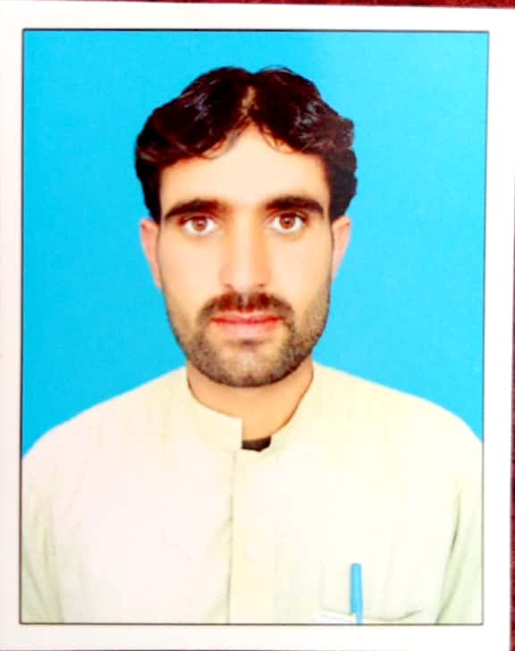

SHER REHMAN
Permanent Add:Village Bazar Zakha Khel, Tehsil Landikotal District Khyber.
Postal Address: P/O Box and Landikotal District Khyber .
Contact: 0333-3225333
Email: sherrehman214@gmail.com

OBJECTIVE:
To join an organization where I can grow on the basis of my personal abilities and to provide effective and efficient service to the best of my knowledge& expereince. To work devotedly in dynamic environment to fullfill the organization and personal goal.

PERSONAL INFORMATION:
- Father Name : Saif Ur Rahman
- Nationality : Pakistani
- Date of Birth : 22-02-1993
- Religion : Islam
- Domicile : District Khyber
- Gender : Male
- Marital status : Married
- CNIC : 21203-5628991-7
- Disability : No
Certificate / Degree | Year | Obtained Marks /Total Marks | Grade | Institute/Board
S.S.C | 2009 | 584/1050 | C | BISE Peshawar
F.A | 2011 | 637/1100 | C | BISE Peshawar
B.A | 2014 | 241/550 | 3rd | University of Peshawar
B.A | 2016 | 1100/632 | C | AIOU Islamabad
PTC | 2012 | 573/900 | B | AIOU Islamabad
CT | 2015 | 555/900 | B | AIOU Islamabad
- QUALIFICATION:
- COMPUTER AND OTHER SKILLS:
- Microsoft Office
- Windows installation
- Adobe Photo Shop
- Internet Exploring
- Medical Health Diploma (Two years) from KPK Medical Faculty.
- EXPERIENCE:

Five years experience in Polio field as a Area Supervisor at Tirah Bazar –A up to now working.
- Four year Eperience as a teacher at GPS Pastokai Bazar Zakha khel on a contract basis.
- LANGUAGE:

Pashto
- Urdu
- English
- Hobies:

Cricket Playing
- Internet Browsing

