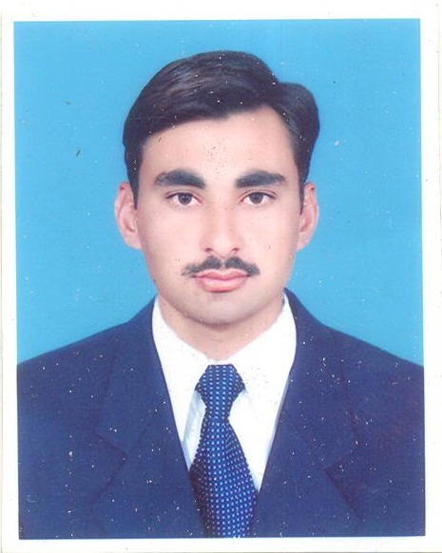
Resume
Mudassar Iqbal
Chak No 20 J.B khanky Tehsil chak Jhumra Faisalabad
Ph#0342 5801226, 0304 6787872

Objective

To accept challenging position in distinguished organization and utilized personal ability to
Provide effective and efficient services to achieve intended results.
Personal Data

Father Name: Muhammad Rafique
Date of Birth: 04-04-1989
CNIC #: 33101-2653917-5
Domicile: Faisalabad (Punjab)
Marital Status: Married
E mail: Mudassariqbal176@gmail.com
Academic Qualification

Degree | Year | Marks / Grade | Institute/Board
Matriculation | 2004 | (2nd) | B.I.S.E Faisalabad
I.CS | 2006 | (2nd) | B.I.S.E Faisalabad
B.A | 2008 | (2nd ) | Punjab university( FSD)
M.A (Economics) | 2010 | (2nd) | Sargodha University(FSD)

Computer Skills

        - well command in MS Office Management
        - Proficient in MS Office & Excel
        - Internet

- other Skill highlights ; 1 strong decision maker 2 service focused
- 3 complex problem solver 4 innovative

Experience

- 3 Month Internship In Education
- 6 Year Experience In WHO As UCPO (2013 to 2019)
- 2 Year Experience In CTC As UCPO (TPPP) continue

Extra Curricular Activities

- Reading News Paper & Quran
Languages = fluent in urdu , Punjabi, ENGLISH

REFERENCE

- will be furnished on demand (if required)

