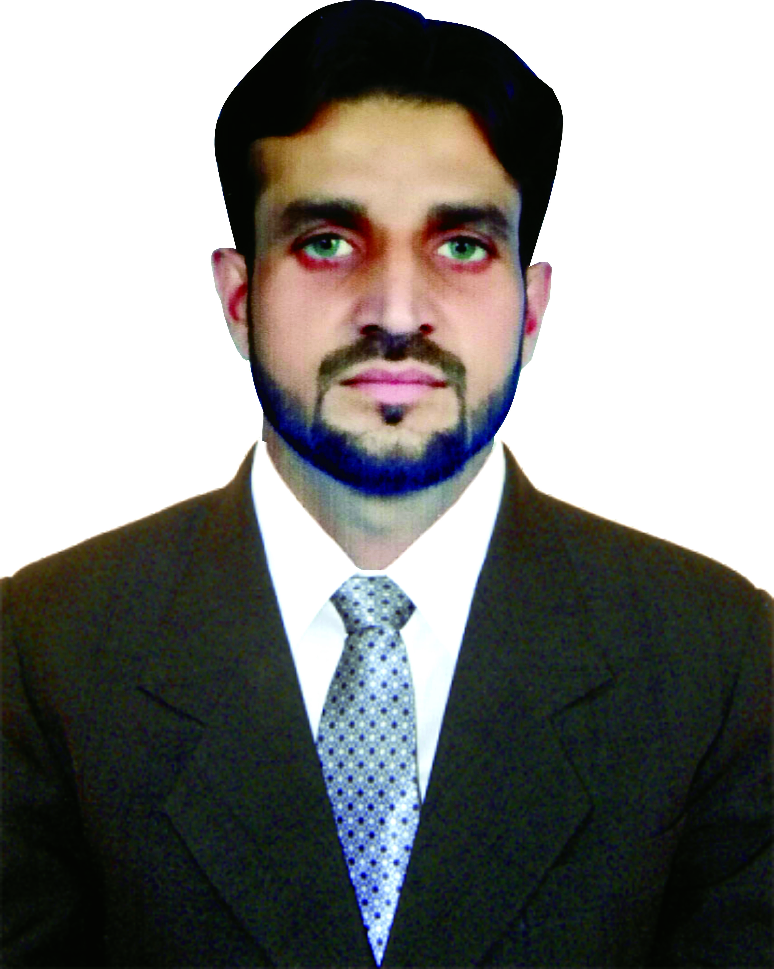
Curriculum Vitae

SAAD HAFEEZ SHAH
Objective
I am always ready to help others without any expecting return from them & I always ready to face any challenge in our society.
Personal Profile
Father Name : Hafeez Ullah Shah
Date of birth : 08-05-1989
CNIC # : 14301-4910026-1
Gender : Male
Marital Status : Married
Religion : Islam
Domicile : Kohat (KPK)
Nationality : Pakistani
Contact No : +92-333-3773330
Email Address : syed.shah2220@gmail.com
Permanent Address : Muhammad Nagar Chowk Pindi Road Kohat,
Near Gunner Line
Academic Qualification Profile
Certificate & Degree | Year | Board/University | Marks/CGPA | Percentage
Bachelor of Science in Social Work | 2015 | KUST Kohat | 2.51/4 | 62.75%
FSc (Comp Science) | 2010 | BISE Kohat | 637/1100 | 57.90%
SSC (Science) | 2008 | BISE Kohat | 555/900 | 61.66%
Professional Experience
Organization Type REPID In Lakki Marwat
Leave No GIRL Behind (LNGB) Project
- Duration: Work from April 2021 to Till Date
- Designation: SO ( Social Organizer )
- Organization: REPID In Lakki Marwat
Organization Type WHO Kohat
- Duration: Work from Sep 2014 to Feb 2020
- Designation: TTM ( Temporary Tehsil Monitor )
- Organization: WHO Kohat
- Duration: Work from 2 Mar 2020 to 28 Feb 2021
- Designation: UCPO ( Union Council Polio Officer )
- Organization: CTC ( Chip Training & Consulting )
Responsibilities of WHO / CTC
- Pre Campaign Monitoring / Activities
- During Campaign Monitoring / Activities
- Post Campaign Monitoring / Activities
- AFP Surveillance
- Support Extensive Out Activities
- Social Mobilization At Union Council Level
Others Experience
- Psychiatric OPD in KDA Hospital Kohat
(Certificate Pending)
- Community Medicine KMU Kohat
(Certificate Pending)
- Child Protection Unit District Kohat
(14/Mar/2013 to 23/May/2013)
- Nishter Special Education Centre Kohat
(20/Sept/2012 to 10/Jan/2013)
- Ufone franchise Kohat. Post of CSR
(12/Mar/2010 to 15/Aug/2010)
- Warid franchise Kohat. Post of CSR
(15/Apr/2008 to 15/Sept/2008)
Computer Skills
- MS Word
- MS Excel
- MS Power Point
- Networking & Cabling
- Windows Installation
- Working In Data Base
- Operating System
Distinguish Features
- Can work for long hours
- Can take challenges with confidence
- Under-take responsibility easily & confidently
- Good relationship building skills
- Keen sense for details
Hobbies/Interests
- Bat Minton
- Social Works
- Blood Donation/ Friendship
Languages
- Urdu
- Pashto
- Hindko
- English
- Punjabi

