***CAREER OBJECTIVES:***

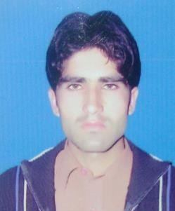

Profile

## *Muhammad Usman*

***Father’s Name****:*

*Ali Man Shah*

***Date of Birth:***

*11-04-1990*

***Add :****Phando Road police Chowki opp Hira Cambridge high School.*

***Religion:***

*Islam*

***Domicile:***

*Peshawar*

***Nationality:***

*Pakistani*

***CNIC****:17301-8146412-1*

***Cell***

*0313-9943698*

***References:***

*Available on request*

***HOBBIES:***

*Long Driving Internet, playing Cricket*

*Reading News Paper*

*To serve an organization that utilizes my potential in the* best way for the accomplishment of personal and organizational goals to serve my community in the best possible way.

# *EDUCATION:*

Certificate/Degree Institute Passing Year

|  |  |  |
| --- | --- | --- |
| *S.S.C* | *BISE Peshawar* | *2007* |
| *F.sc* | *BISE Peshawar* | *2009* |
| *B.sc* | *UOP* | *2012* |
| *DIT* | *TTB* | *2016* |
| *C.T* | *AIOUP* | *2014* |
| *Master* | *Uop* | *2017* |

## *Computer skill*

* **CIT** 6 months certificate from aptech.

# *Experience:*

## *5 years Experience in teaching.*

* *1 year experience assistant plus storekeeper*
* *3 years experience voice principal as a al- mansoor model school Peshawar.*
* *16 months experience as a computer operator as a different school and two shops Khyber composing and chamkani composing shop.*
* *6 months experience as a polio vaccinetrr .*
* *1 year experience as a area supervisor*
* *6 months experience as a polio mobile team worker*
* *7 years experience in shop store man book copies*
* *7yesrs editing plus composing documents on computer as a computer operator*

# *Sport Certificate:*

* + ***Cricket***

***LANGUAGE PROFICIENCY:***

* *English (Writing, Speaking, Listening, Reading) very good*
* *Urdu (Writing, Speaking, Listening, Reading) Excellent*
* *Pashto (Writing, Speaking, Listening, Reading) Excellent*