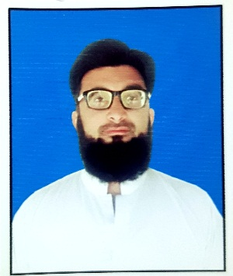**CURRICULUM VITAE**

**Personal Information:**

Name: Muhammad Sohail

Father Name: Sabih ur Rehman

Marital Status: Married

Nationality: Pakistani

CNIC# 37405-4384894-1

Mobile: 0332-5105731, 0311-5105731

Email: msuhailktk9@gmail.com

Postal Address: Village and Post Office Tarkha Koi, Teshil and District Karak. KP.

**Profile:**

* A quick learner.
* Able to work independently and as a group member achieving high efficiency level with a little direction.
* I am able to understand things quickly and easily.

**Education:**

|  |  |  |  |  |  |
| --- | --- | --- | --- | --- | --- |
| **Academics** | **Session** | **Percentage** | **Division/ Grade** | **Board** | **Sub/ group** |
| SSC | 2009 | 63% | 1ST | BISE KOHAT | SCIENCE |
| FSc | 2011 | 56% | 2ND | BISE KOHAT | PRE-MEDICAL |
| B.A | 2017 | 67% | 1ST | AIOU ISLAMABAD | ARTS |

**Professional Experience:**

|  |  |  |  |  |
| --- | --- | --- | --- | --- |
| **Post** | **Organization** | **From** | **To** | **Total Duration** |
| **TTM** | **World Health Organizatuon** | **June, 2017** | **April, 2022** | **3 Year, 9 Months.** |
| **TUSP** | **World Health Organizatuon** | **May, 2022** | **Till Present** | **1 Month** |

**Languages Known:**

|  |  |  |
| --- | --- | --- |
| **Language** | **Spoken** | **Written** |
| English | Fair | Fair |
| Urdu | Good | Good |
| Pashto | Native | Native |