SAJJAD AHMAd
Resume

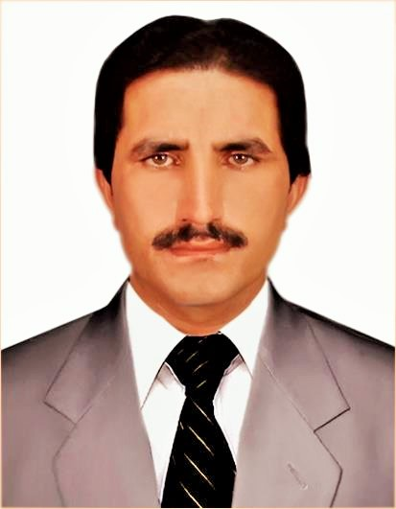
Mailing Address:

Sajjad Ahmad C/O: DHO Office Wana (SWTD).
Cell # 0301-8792384 ,0331-8197296
E-mail : sajjad wazir86@gmail.com
- OBJECTIVES
I am confident and enthusiastic person with ability to learn and adapt quickly to new challenges and to handle difficult situation under pressure. I have an organized approach with good communication skills, which enables me to work effectively either on my own or as a part of the team.
- ACADEMIC QUALIFICATION

Year | Qualifications | BOARD / UNIVERSITY
2010 | M.Sc  (Library & Information Science) | University of Peshawar
2007 | B.Sc(Computer Science) | Gomal University D.I.Khan
2003 | F.Sc ( Computer Science) | B.I.S.E Bannu
2001 | S.S.C (Science) | B.I.S.E Bannu


- WORK EXPERIENCE



- Worked as a compaign support person(CSP) with (WHO) from 20-11-2009 to 15-12-2010
- Worked with REHBAR Organization(CMAM) Community Management of acute Malnutrition/from Unicef as community outreach worker from 01-5-2011 to 30-3-2012.
- Worked with ComNet(CTC) as a Social Mobilizer from 02-07-2012 to 28-02-2014.
- Worked as (UCPO)Union Council Polio Officer with (CTC) in UC Dab Kot ,Dazha Dazha Ghundai and Zeri Noor from August 2nd 2019 to February 2021.
- Working as (UCPO) Union Council Polio Officer with (CTC) from march 2021 up till now.

Responsibilities:

- Operational work during every polio campaign.
- Monitoring of area supervisors and teams during campaign.
- Working under update micro plans and social maps.
- Monitoring of the refurbishment work.
- Team training (Facilitator).
- Documentation and its Reports after every campaign.
- COMPUTER SKILLS

- MS word
- MS Excel.
- MS Power Point.
- Internet and Email.
- INTERESTS
- Traveling
- Net browsing
- Reading
- Writing
- LANGUAGES
- English (Reading, writing,speaking)
- Urdu (Reading, writing,speaking)
- Pashto (Reading, writing,speaking)
- PERSONAL INFORMATION
- Fathers Name : Muzamil Khan
- Date of Birth : 08-05-1986
- Domicile : S.W.T.D
- Nationality : Pakistani
- Religion : Islam
- CNIC # : 21708-5854728-1
- Marital Status : Married

- REFERENCES

To be available on Demand.

