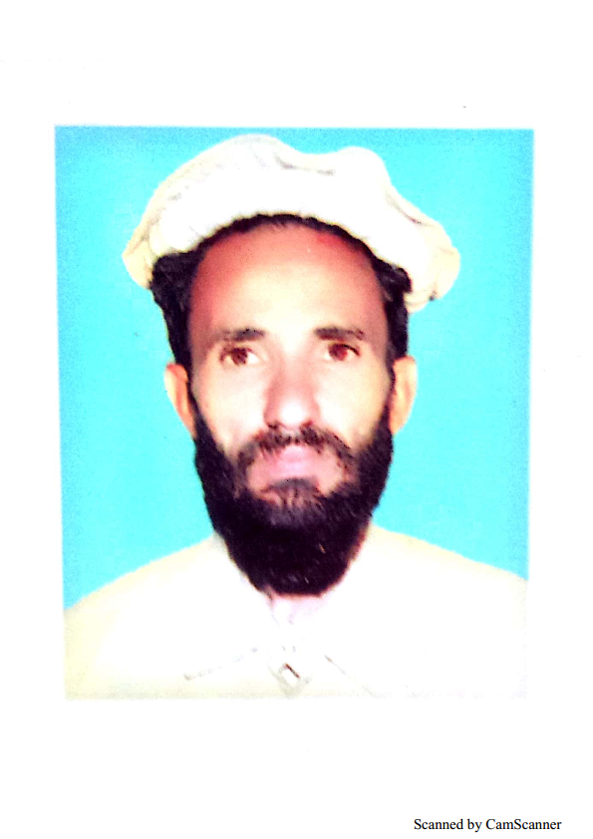 Movela Ayaz Khan

**Personal Information**

* + - **Father’s Name Shaikh Namir**
    - **Date of Birth 15-06-1977**
    - **Domicile Dist:N.W**
    - **Religion Islam**
    - **Marital State Married**
    - **CNIC no 21505-9093729-5**
    - **Contact No 03329801773 OR 03088085454**
    - **Address Village Khaddi Tehsil &p/o**

**Mir Ali D.N.W.**

OBJECTIVE :

* Being a qualified & professional person, I am motivated to achieve the positive GOALS of a project or an organization.

**ACADEMIC QUALIFICATION:**

|  |  |  |  |
| --- | --- | --- | --- |
| S.NO | Exam | Year of passing | Board/University |
| 1 | SSC(science) | 1992 | BISE Bannu |
| 2 | F.Sc | 1996 | BISE Bannu |
| 3 | BA | 2001 | U.S.T Bannu |
| 4 | MA | 2014 (Part 1) | U.S.T Bannu |

**PROFESSIONAL QUALIFICATION:**

|  |  |  |  |
| --- | --- | --- | --- |
| S.NO | Exam | Year of passing | Board/University |
| 1 | Dispenser | 1997 | MEDICAL FECALTY PESHAWAR |
| 2 | PTC | 1999 | AIOU D.I Khan |
| 3 | DIT | 2004 | BTE PESHAWAR |

**EXPERIENCE :**

* 12 Years in computer I.e. Soft ware and hard ware
* 3 years teaching experience as Lecturer at **Tochvi Collage of Information Technology Mir Ali DNW**.
* 2 years (FREE TUETION) as a president of social program **SHAHEEN WELFAIR SOCITY DNW.**
* 3 years experience in **“POLIO (As US Unite Supper visor)**

**PROGRAM”**.

**COMPUTER SKILLS :**

* MS Office i.e. MS Excel and MS Word.
* Inpage and Corel Draw
* Internet

**Languages :**

* ***PASHTO :*** *Excellent in writing, Reading & Good in*

*Speaking.*

* ***URDU :*** Excellent in writing, Reading & Good in

*Speaking.*

* ***ENGLISH :***  Excellent in writing, Reading & Good in

*Speaking.*

* **REFERENCEs :**
* Email: [movelaayaz454@gmail.com](mailto:movelaayaz454@gmail.com)
* Cell No: 0308 8085454 and Whatsapp No: 0332 9801773
* Kousar Books and photo state Center main Chook Mir Ali Bazar DNW.

OR

* Adnan Mobiles Center Supper Market Khaddi DNW. Contact.0928 220291

CNIC Copy is attached,

