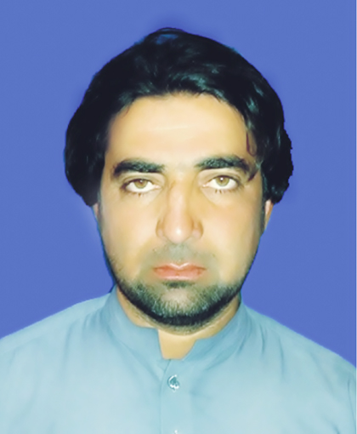
Muhammad Hashim
Curriculum Vita
Address: Sheta Khel Village Issori P/o Tehsil Mir Ali NWTD.
Watts App :0334-5371451 / Mob: 03249811988

OBJECTIVE

Looking forward to pursue challenging career, which enables me in understanding of organization. And further be part of the solution to the problems, eagerly involved in continuous learning, upgrading knowledge and skills, looking fervently towards further future growth.

PERSONAL INFORMATION

- Father’s Name : Asmat Ullah
- Date of Birth : 05-05-1989
- N.I.C No. : 21505-3060877-9
- Domicile : NWTD
- Marital Status : Married
- Gender : Male
- Nationality : Pakistani
- Religion : Islam
ACADEMIC QUALIFICATION

EXAM | Year | Marks | Board
B.Ed | 2016 | 542/1050 | AIOU Islamabad
DIT | 2015 | 1094/1400 | BTE Peshawar
MA (Urdu) | 2013/14 | 495/1100 | UST Bannu
B.A | 2010 | 299/550 | UST Bannu
F.A | 2007 | 616/1100 | BISE Bannu
SSC | 2005 | 640/1050 | BISE Bannu
- Language Skills:
- Speaking Writing
- English : Good Excellent
- Urdu : Excellent Excellent
- Pashto : Excellent Good

- Experience
- Work as a Data Entry Oprator in Muslim Aid from 1/7/2014 to 31/12/2017 at bannu.
- Work as CHW with CTC from Feb 13/2018 to May 31/2019 at NWTD.
- Work as Area Supervisor With CTC from 1st june 2019 to 31 May 2020at NWTD.

Refrences:
Muhammad Azmat Ali Shah
M& E Muslim Aid
Cell No : 1: 03339403394
2: 03139056905

