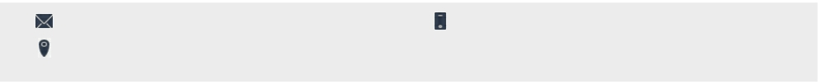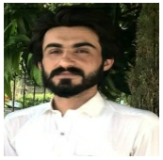

**Naeem Ullah English literature**

My objective is to build and enhance my professional skills and experience in a reputed and dynamic organization that gives me the opportunity to evolve in a professional manner. I am seeking to apply my abilities to fill an important role in an organization as a team member. I am a dedicated team player, who can be relied upon to help an organization achieve its goals.

naeemullah5021@gmail.com 03109596591

House no#44 New Defence Colony/Behari Colony Warsak road, Peshawar

**EDUCATION**

**BS -ENGLISH**

Government Degree College Hayatabad Peshawar Affiliated with UOP (September 2017-May 2022)

CGPA: 3.26

**F. Sc (Pre-Engineering)**

Chokara Science School and College Chokara, Karak (September, 2014- April, 2016)

**EXPERIENCE**

▪ Working as a Social Mobilizer and a transit team worker at Cantonment Board General Hospital Peshawar (from March 2019 to till date)

▪ Worked as field assistant in Measles and Rubella campaigns, COVID-19 Campaigns organized by WHO

* Computer Operator (from july 2019 to till date) at Corvit Institute Peshawar

**TRAINING COURSES**

Microsoft Office (March, 2014 – May, 2014)

HH academy, Peshawar

This course focused on developing the following

skills:

▪ Create and Send E-mail messages

▪ Create documents

▪ Create presentations ect

**SKILLS**

▪ Microsoft office

▪ Power Point Presentation

▪ MS – Excel

▪ Internet Browsing, Downloading, E-mail etc

▪ Basic Networking.

▪ Typing up to 25wpm

▪ Self-confident hard working and result oriented

▪ Proactive to do work in challenging environment, willing

to accept responsibilities

▪ Flexible and able to adapt in various conditions

▪ Cooperative and a good team worker.

▪ Organizational management and Planning

▪ Verbal and Written communication

**CERTIFICATES**

▪ National Certificate of Vocational Qualification in Information Technology (Computer Operator) from (KP-TTB) April 2022

* TESOL Methodology MOOC 2022

▪ Career Counselling /Planning (24th Feb, 2022)

▪ ICAP Quiz Competition 2018

* National Youth Carnival 2017

**LANGUAGES**

▪ Pashto- Native Language

▪ English- Speak and read /write with high proficiency

▪ Urdu- Speak and read/write with high proficiency

**INTEREST**

▪ Playing Computer/Mobile games

▪ Playing Cricket

▪ Music/Songs

▪ Reading Books

▪ Watching Movies