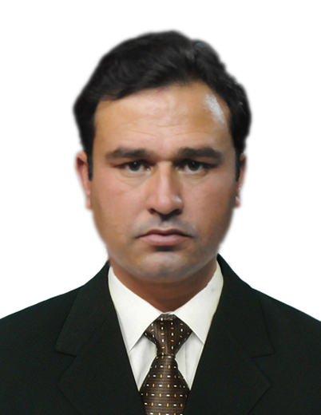

KAMRAN KHAN

 +923439883188
+923085797481
Email: Kamrankhanst10@gmail.com

Personal Statement

I am a young individual who likes the challenging environment, to accomplish with excellence by leading an efficient teamwork even in a high-pressure environment fot the betterment of humanity and ur organization.

Personal Information

Father Name : khyal Anwar
Date of Birth : 15/03/1986
NIC No : 21203-4991789-9
Marital status : Married
Religion : Islam
Gender : Male
Nationality : Pakistani

Home address : UC station Haji Zaman kalai, Near DHQ hospital
Landi kotal
Domicile : KHYBER

Province : Khyber Pakhtoonkhwa

Academic Qualifications

EXAM | SUBJECT | Year | CGPA+  Division | BOARD/UNIVERSITY
M.A | Sociology | 2012 | 1st div | University of Peshawar
B.A | Sociology,  Political science | 2009 | 2nd | University of Peshawar
F.sc | Pre-eng | 2004 | 2nd | B.I.S.E Peshawar
Matric | sciences | 2002 | 1st | B.I.S.E Peshawar

experience

1.Presently I am working as Union Council Communication Officer with Professional Employers Private Limited for Polio Eradication Programme Pakistan at UC Station Landi Kotal, District Khyber , Khyber Pakhtoonkhwa, Pakistan since 29 July 2020 up to date.

2. One year experience as Social Mobilizer with Chip Training and Consultant for polio eradication at UC Station Landi kotal.
including:
a. Social mobilization and awareness for polio before campaign.
b. Papers, Posters and banners dissemination.
c. Attending awareness session at different places.
d Attending and managing workers training.
e. Providing teams with essentials like ice, kits ,vaccines etc
f. Carrying out monitoring and evaluation during campaign of different AICs and teams.
g. Attending evening meetings with administration and UC staff.
h. Forwarding minutes to the higher command.
I. Attending different trainings at Landi kotal and Peshawar .
J. Convincing refusals, Still N/As and covering them .
K. Carrying out tallysheet and data analysis.

3. One year experience as Tehsil coordinator and social mobilizer for tehsil Land kotal Khyber district with Global Foundation Rawalpindi (A human rights organization) including:
a. Coordination and mobilization for human rights.
b. Papers and banners dissemination about human rights at different places specially women rights.
c. Weekly, monthly and yearly report writings about human rights situation in my area concern
d. Setting up teams of eight volunteer workers and assigning tasks to them.

4. One year experience as volunteer worker with Sahil foundation.
5. One year experience as teacher and cousellor with Bacha khan foundation.
6. Field work with SPARC NGO.
7. Six Months Experience as Banca Sales Consultant With EFU Life Assured insurance company at United Bank Limited University of Peshawar Campus branch.

ccccca

computer skills

- Typing speed 25 w.p.m in English tested on typing master 2011.
- Microsoft Word.
- Microsoft Excel, able to design different sales and invoices forms with different graphs.
- Microsoft Power Point, able to present slides using different animations and graphics.
- good communicator.

Hobbies

- Internet surfing.
- Involve in Creative and Innovative Activities.
- Reading books and have wide knowledge on Current Affair.
- playing football etc

Language Fluency

- Foreign Language: English,
- Local Languages: Urdu and pashto

REFERENCE: Sameedullah (Political Person)
: SAIRAJ UDDIN (GENERAL PRACTIONER UC STATION)
:SULTAN MUHAMMAD (GENERAL PRACTIONER UC STATION)

