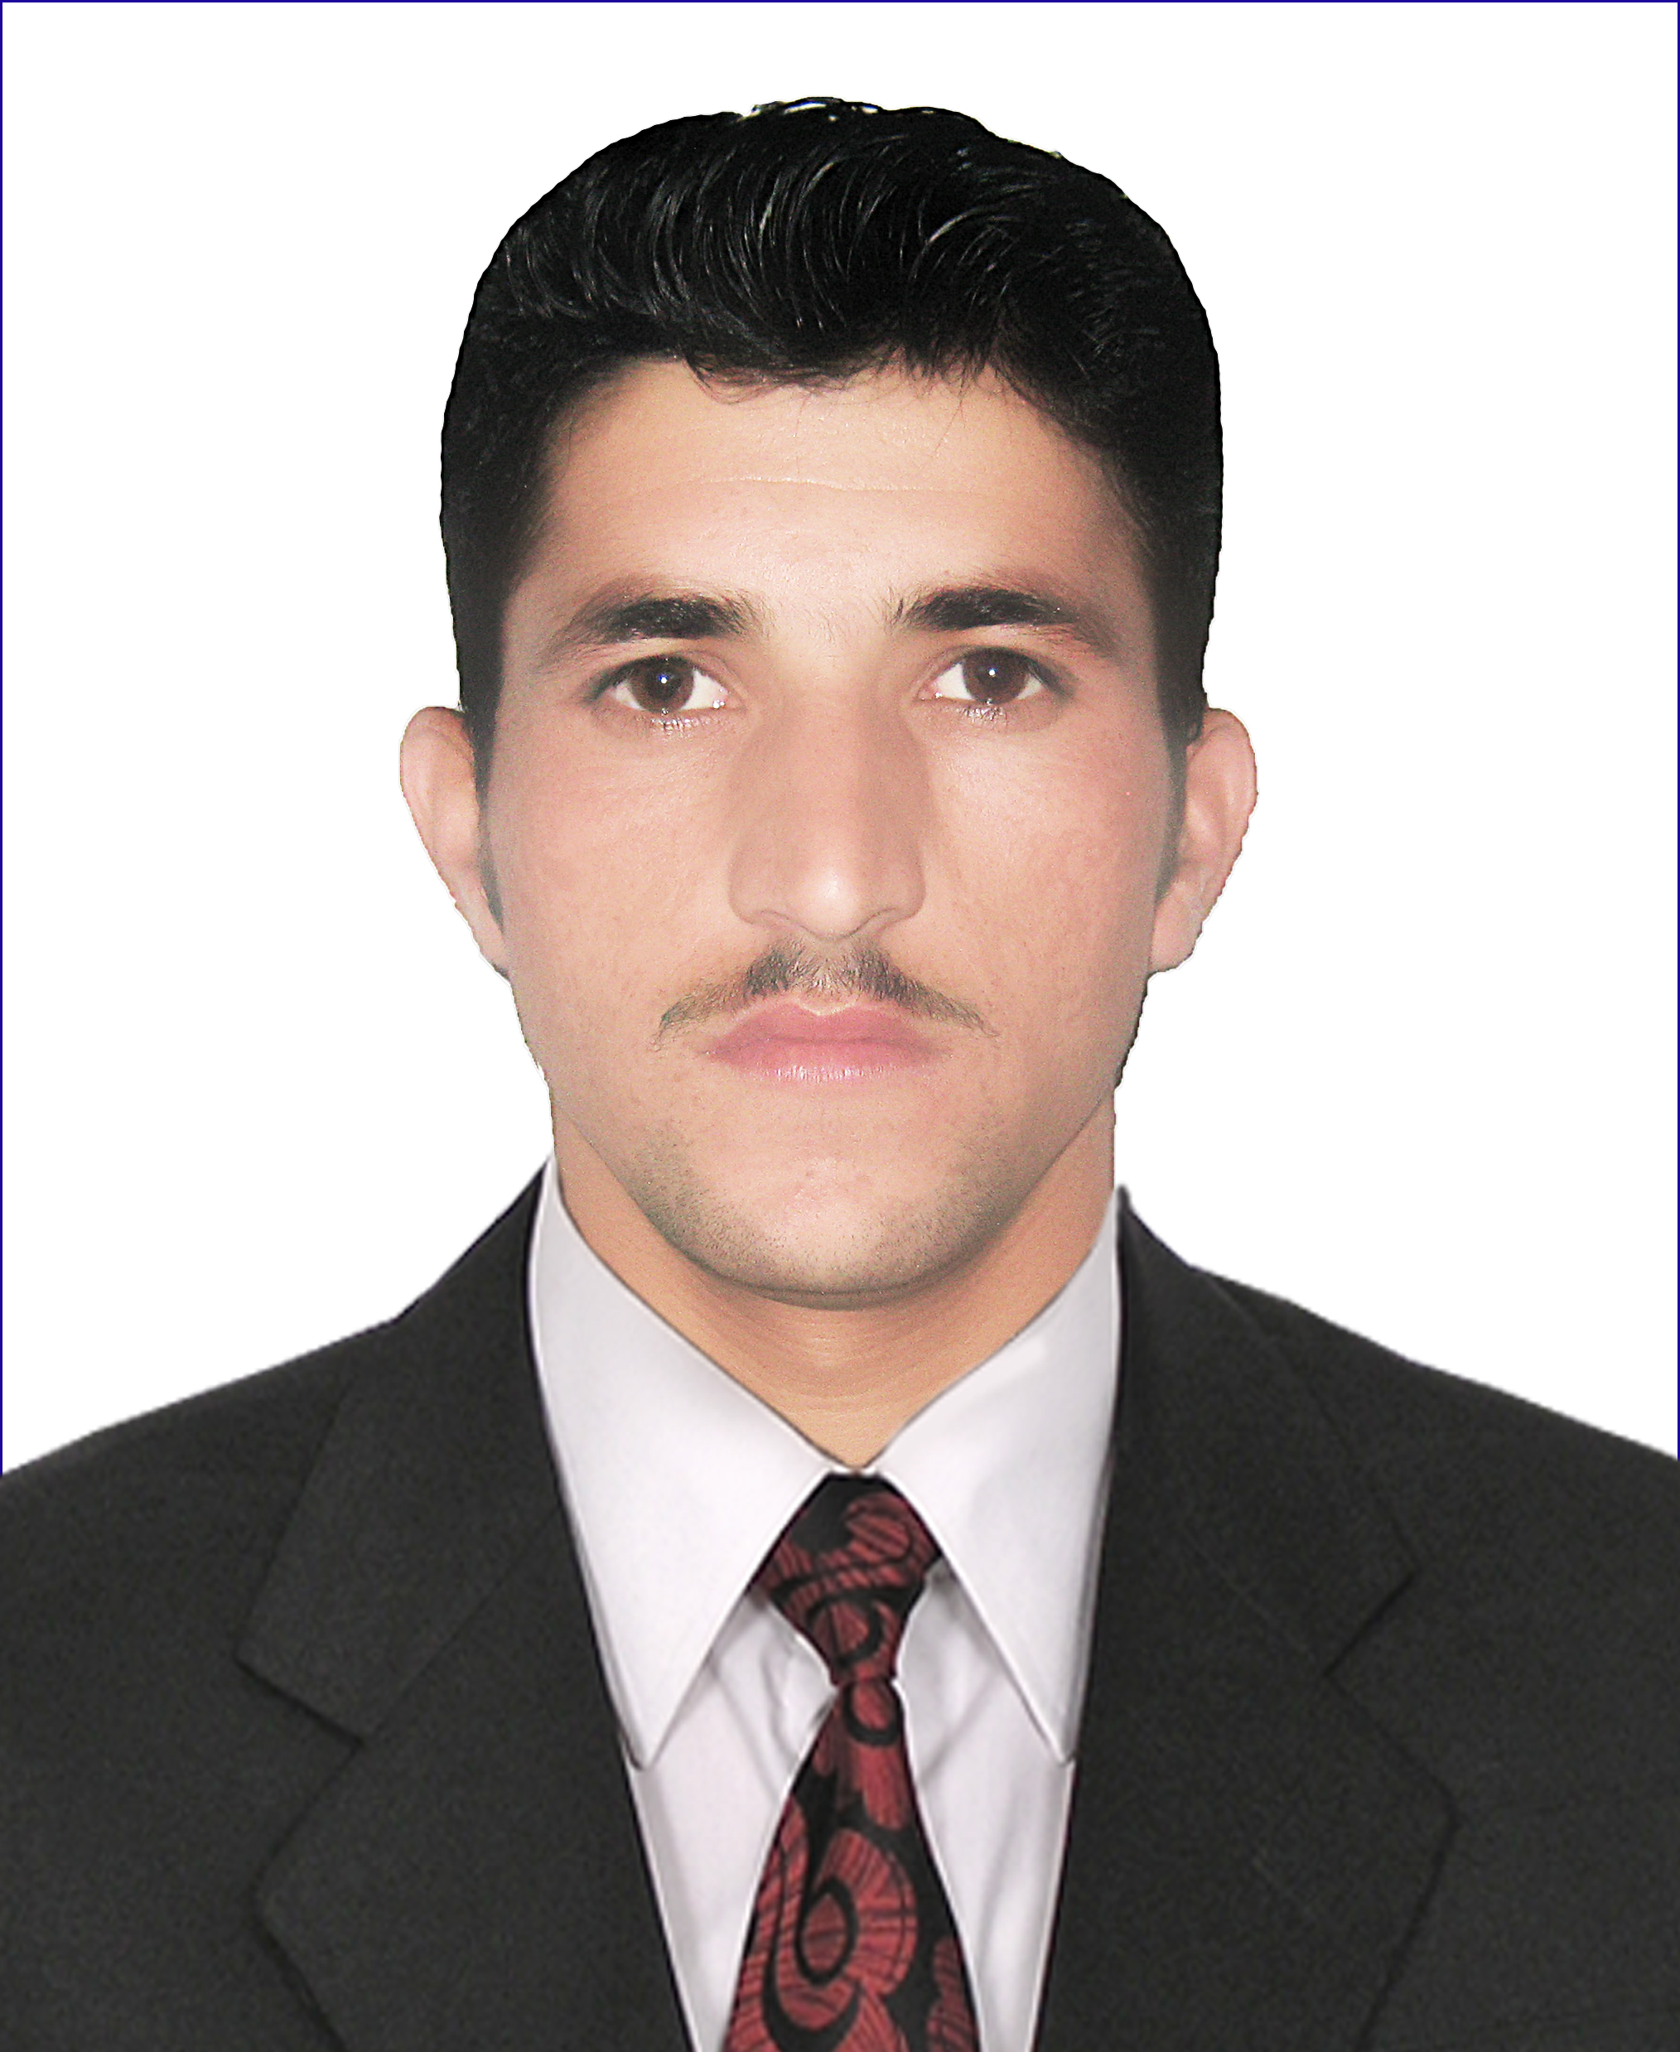
PERSONAL INFORMATION
Father Name: Abdul Wahab
Religion: Islam
Nationality: Pakistani
Date of Birth: 14-02-1995
NIC Number: 21203-7671469-1
Domicile: Khyber Tribal District
Mailing Address: Near DHQ Landi Kotal Khyber Tribal District
Cell Number: (1) +923049435210 (2) +923402025225

VISION & OBJECTIVES

I believe in smart work and am a devoted person to my duty. My desire is to enhance my skills and potential. I am seeking an environment which is conductive to learning, where I can get and provide a lot, and I wish to apply academics knowledge to the challenging tasks leading to the growth and development of the organization.

QUALIFICATION

- SSC (Science) B.I.S.E Peshawar 2012
- FSc (Pre-Medical). B I S E Peshawar 2014
- BSc (Zoology) University Peshawar 2016
- MSc (Zoology) Qurtaba University 2019

EXPERIENCE \PROJECT DONE

- 2 years experience as Health Facilitator Officer in "Sehat Sahulat Program"
- 2 years experience as Ward Clerk in DHQ Hospital Landi Kotal.
- 1 year experience as Computer Operator in Ijaz Digital Services Landi Kotal Bazar.
- 6 month experience as Polio Worker in EPI.
- 1 year teaching experience in Tatara Public High School.

COMPUTER SKILLS

- MS Windows (98, XP, Vista),
- MS Office Suite,
- Internet.
- Typing

LANGUAGES

Read, Write and Speak:
- English,
- Urdu,
- Pashto.

REFERENCES
- Available upon request.

