CURRICULUM VITAE

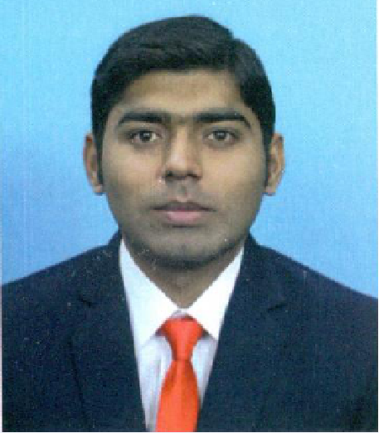

Dr. TAUQEER AHMED NASIR

Mobile:+92 3004677572

WhatsApp:+92 3004677572

E-mail:[tauqeermbbs@gmail.com](mailto:tauqeermbbs@gmail.com)

# Objective:

Seeking a position of General Physician where my commitment to patient welfare and sound understanding of the preventive healthcare in a challenging work environment and to utilize sound understanding of preventive measures, ailment diagnosis, medications, advanced medical procedures and capabilities to handle patient needs on time.

# Profile:

Self-motivated and hard working with zeal for professional progress and career advancement through determination and dedication.

# Qualification:

* **MSPH** (Master of Science in Public Health) from Al-Shifa School of Public Health Rawalpindi, Quaid-i-Azam University Islamabad, Year 2021.
* **MBBS** (Bachelor of Medicine and Bachelor of Surgery) from Xinjiang Medical University, Urumqi. People Republic of China, Year 2017.RMP(Pak) PMC (Pakistan Medical Commission)
* **HSSC** (Higher Secondary School Certificate) from Al-Suffah College, Federal Board of Intermediate & Secondary Education Islamabad, Pakistan. Year-2011
* **SSC** (Secondary School Certificate) from Ailyan’s Higher Secondary School, AGA Khan University Examination Board, Pakistan. Year-2009.

# Key Skills:

* Diagnosis and Treatment of Diseases
* Preparing Medical care strategies
* Assurance of patient confidentiality
* Experience in infection control
* Ability to coach junior medical staff, Quick in problem resolution
* Stress management capabilities, Good teamwork capabilities
* Flawless management of patient records and documents.
* Good knowledge of medical equipments.
* Well versed with all the medical terminologies.

# Professional Experience(+03 Years):

* Currently working as **Freelance Occupational Health Trainer** in Islamabad, Pakistan.
* Starting working in **PIMS Hospital Islamabad** as a **house Officer** from 21/06/2021 to 20/06/2022.
* Worked as **TRF+ Field Researcher** in various Districts of Punjab by Mott MacDonald Limited UK from 19th Dec 2018 to 25th Jan 2019.
* Worked as **House Job Officer** in District Head Quarter Hospital Mianwali, Pakistan from 09th Oct 2017 to 12th Nov 2018.
* Worked as **Interne House Job Officer** from 15th May 2016 to 14th May 2017 as follows:
  + - Pediatrics
    - Cardiac
    - Surgery
    - Medicine

# Key Responsibilities:

* Delivering the various Heath education trainings like First Aid, Emergency and Heat Stroke program as Freelance trainer.
* As +TRF Field Researcher, Carry out survey work to check the provision of Health facilities in various Districts Hospitals to ensure future Health requirements under UK Aids Program.
* Responsible for checkup of the patient and giving prescriptions.
* Handling the emergency cases.
* Assisting the senior doctors in surgery and other operations.
* In case of requirement performing the pathological duties.
* Checking the reports and accordingly diagnosing the disease and giving prescription.
* Assisting the senior doctor in checking the patients.
* Diagnosing the disease as per the symptoms.
* Observing and performing the examination of samples for disease diagnose.
* Learning the diagnostic methods and equipments.
* Periodically meeting the patients and observing their improvements and making reports.
* In case of emergency giving the basic treatment to the patients.
* Helping other medical staff in performing their duties.
* Assisting in the daily supervision of orthopedic surgeons and nurses.
* Attending surgery trainings and procedures to add knowledge for the job of an orthopedic surgeon.
* Conducting minor surgeries under the supervision of surgeons.
* Evaluating reports and data to ensure the necessary care and consideration is taken success of the surgery.
* Responsible for regular checkup and improvement in the patients.
* Performing small surgeries.
* Giving training to the interns and new joined.
* Meeting to MRs

# Workshops & Trainings Seminars:

* 03 Days Neurosurgical training workshop by Central Asia Neurosurgery International
* Pediatrics conference in DHQ Hospital Mianwali
* A Seminar on Communicable Diseases at DHQ Hospital Mianwali
* General Awareness training on Patient & Doctor’s Safety.
* 10th Annual Public Health Conference TACKLING INEQUITIES IN HEALTH organized by Health Services Academy, Islamabad.
* **COVID-19:** **Operational planning Guidelines & COVID-19 Partners Platform to support country preparedness & response** **From WHO (World Health Organization) Health Emergencies Program.**
* **Infection Prevention and Control (IPC) for Novel Corona virus (COVID-19) From WHO (World Health Organization) Health Emergencies Program.**
* **Let’s Gear Up to Volunteer and Defy COVID-19 From The Muhammad Bin Rashid University UAE of Medicine and Health Sciences (MBRU) Community Immunity Ambassador Program.**
* **Let's Break the Chain of COVID-19 Infection From The Muhammad Bin Rashid University UAE of Medicine and Health Sciences (MBRU) Community Immunity Ambassador Program.**

# Computer Skills:

* MS-Office (Excel, Access, Word, Power Point etc)
* Various latest window versions like 8, 7, Vista and others professional software, Internet & E-mail

# Extra Curriculum Activities

* Reading books
* Travelling
* Playing and watching cricket
* Internet surfing
* Sports Watching
* Health News Alerts
* Innovation in Health Monitoring equipment
* Reading Islamic History

# Personal Detail:

Date of Birth : 1992

Nationality : Pakistani

Sex: Height : Male, 5’-9”.

Languages : English, Urdu, Chinese, Hindi, Punjabi

Marital Status : Single

Visa Status: Visit

CNIC Detail: 38302-3768498-1

**Passport Detail:**

Passport No : EK9824982, Pakistan

Date of issue : 21st Feb, 2017

Date of expiry : 21st Feb, 2027

# References:

Are available upon request