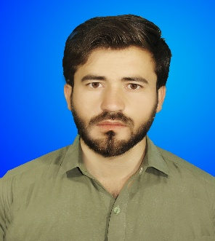 **Zia u Din Khan**

CV

Cell#: 0315-3801896

Email : ziauddink553@gmail.com.

**OBJECTVES:**

To enhance my knowledge and capabilities by working in a dynamic organization that prides itself in giving substantial responsibility to new talent.

**PERSONAL INFORMATION:**

* Father’s Name: Haji Zafran
* Date of Birth: 16/09/1997
* CNIC No: 54203-2523186-3
* Religion: Islam
* Domicile: chaman
* Union council Zara band (GP1)
* Nationality: pakistani
* Marital Status: Single

**QUALIFICATION:**

* Matriculation Balochistan Board 1st division 61%
* FSc Baluchistan Board 1st division 71%
* Bsc University of Balochistan 1st division 60%
* M.Sc Chemistry University of balochistan 1st division 70%
* MA Islamiat University of Balochistan 1st division 65%

**COMPUTER SKILLS:**

* Application software: MS Office, MS Word. MS. Excel .MS Power Point,inpg
* English language level Six

**EXPERIENCES:**

* 2 Years Experience Teaching
* 6 months experience in NGO (PIDS)
* 1 year Experience as social mobilizer in PRCS
* Currently works as teacher and home tutor

**LANGUAGES:**

* Urdu
* English
* Pashtu

***Applying for post of UCDO District CHAMAN***