

Muhammad Saleem Ullah
Address: Killi Khalozai Aghbarg Samungli Road Quetta
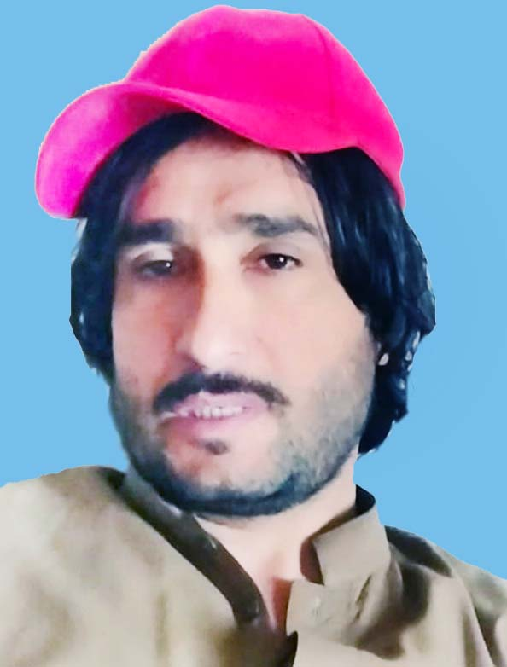

Personal Information

Name Muhammad Saleem Ullah

Father’s Name : Haji Abdullah

Date of Birth : 06-06-1983

Local : District Quetta Balochistan

C.N.I.C : 54400-6924648-3

Nationality : Pakistani

Marital Status : Married

Contact No : 0336-1211920

Academic Qualification

Certificate / Degree | Board / University | Division | Passing Year
B.A | University of Balochistan | 3rd Div | 2004
F.A | Balochistan Board Quetta | 2nd Div | 2001
Matric | Balochistan Board Quetta | 2nd Div | 1998

- EXPERIENCE:

- Ten years working experience Store keeping and auto industry can travel and drive in remote areas. can work in difficult and hard position.

- Typing Course:

- 35 word per minutes typing speed

- LANGUAGES:

- English
- Urdu
- Pashtoo
- Balochi
- Brahvi

Hobbies:

Cricket

