C.V

APPLICATION FOR APPOINTMENT

Subject: APPLICATION /REQUEST FOR APPOINT

Respected Sir,

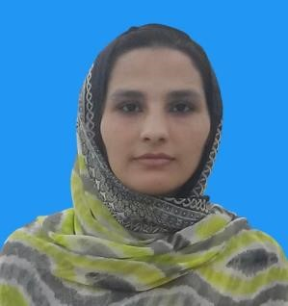With due respect and humble submission I beg to state that I have come to know through reliable source that some posts are lying under your kind control. I offer myself as a candidate for one of this post having following qualifications.

|  |  |  |  |  |  |
| --- | --- | --- | --- | --- | --- |
| Name: - | Hasina Ibrahim | | | | |
| Father Name: - | Ghulam Ibrahim | | | | |
| Domicile: - | Bannu | | | | |
| Date of Birth: - | 13/05/1998 | | | | |
| CNIC :- | 11101-6817918-6 | | | | |
| Present Address: - | village Gharri Mir Alam P/O Badda Mir Abbas Mandan Bannu (28100) | | | | |
| Contact No: - | 03329735011 | | | | |
|  | | | **EDUCATIONAL QUALIFICATION** | | |  | |
| Qualification | | | Total Marks | Obtained Marks | Grade | Name Of institute | |
| Matric | | | 1050 | 623 | C | BISE Bannu | |
| F.Sc | | | 1100 | 677 | B | BISE Bannu | |
| BS Sociology | | | 4500 | 3778 | A | USTB Bannu | |
|  | | | **PROFESSIONAL QUALIFICATION** | | |  | |
| L.H.V | | |  | | | NBP Peshawar | |

**Experience**

* **L.H.V practice of 9Months with KUMORE N.G.O.**
* **1 year practices with KPMD project working in mother and child. & 3 Years self-clinic practice**

Keeping in view the above qualification I hope that you will give me a chance to serve my nation**.**

Thank You for your positive response

Your Obediently Hasina Ibrahim