***MUHAMMAD SALMAN S/O IMTIAZ KHAN***

**PARSOAL INFORMATION**

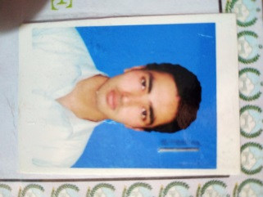**Date of Birth : 01-01-2001**

**CNIC NO : 21506-3199402-3**

**Domicile : K.P.K Bannu**

**Nationality : Pakistani**

**Marital : Un-Married**

**Mobile : 0331-5782082**

**Email : itxsalman305@gmail.com**

**Address : 288/6 Mission Hospital Road Bannu**

**ACADEMIC RECORD**

|  |  |  |  |  |  |
| --- | --- | --- | --- | --- | --- |
| **S,NO** | **Degrees** | **Subject** | **Year** | **Marks** | **Bord/UNI** |
| **01** | **SSC** | **Science** | **2016** | **669/1100** | **Bise Bannu** |
| **02** | **FSc** | **Science** | **2018** | **595/1100** | **Bise Bannu** |
| **03** | **Diploma** | **DIT** | **2019** | **1022/1400** | **Bise Peshawar** |

**EXPERIENCE**

* **02 Year experience in Kashif Traders as a Computer Operator**

**LANGUAGES**

* **Pashto**
* **Urdu**
* **English speaking and writing**