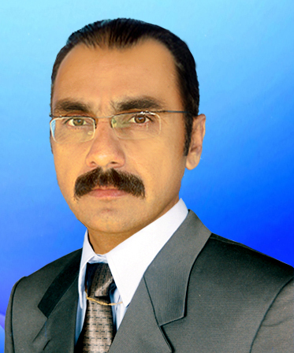
Hafiz Ullah
Curriculum Vitae Working Experience 3 year
Cell: 0333-3622100
Land line:0928-314129
E-mail: hafizdawar277@gmail.com

ADDRESS:
Postal Address: Dawar Mohammad khel P/O Boya, Tehsil Datta Khel, North Waziristan Agency.

Career Objectives

Pursuing a challenging career in a reputable organization that seeks personnel with potential for growth and advancement and where my education, experience, and skills could be utilized in achieving organization’s goal and to be a part of such a dynamic organization where my skills could essentially contribute towards the achievement of organizational objectives. I believe that team work is a trick behind the success of any organization.

Personal Information
Father’s Name : Afsar khan
Date of Birth : 13/03/1982
Religion : Islam
C.N.I.C No : 21501-9276600-7
Nationality : Pakistani
Academic Qualification:
Degree Name : M.A History
Division : 2nd Division.
Completion date : 2017
Institute : UST Bannu
_____________________________________________________________________________________ Degree Name : B.A
Division : 2nd division
Completion date : 2015
Institute : UST Bannu
______________________________________________________________________________
Degree Name : F.A
Division : 2nd division
Completion date : 2001
Institute : Govt Post Graduate College Bannu
_______________________________________________________________________________
Degree Name : S.S.C (Science)
Division : 2nd division
Completion date : 1998
Institute : Tochi Public High School Miranshah
_______________________________________________________________________________
Training and Seminars attended:
- Induction trainings by CHIP training & consulting regarding field work for polio eradication
- One days Seminar on FATA Jirga system at Pearl continental Hotel organized by UNDP
- Five day Training on Customer mechanism organized by HRDC at VIP Guest House Peshawar
- Five days field work on IPV campaign as a Team Assistant
- Two day refresher Training on new Guideline by CHIP training & consulting regarding field work for polio eradication

Experience with Organizations:
(1)
Employer: CHIP Training & Consulting Private Ltd. Islamabad
Duration: 12 September 2017 to 31 May 2020.
Position: Area Supervisor

(2)
Position: Working as a TTM (Tehsil Temporary Monitor) with W.H.O
Duration: One Year

(3)
Position: Working as a UCSP (Union Council Support Person) with W.H.O
Duration: 10 April 2022 to Present Date.

Duties and Responsibilities:

  - To support community health Workers (CHWs) for up to the mark field activities and educating the community about ongoing activities for polio eradication and routine immunization.
  - To provide exhaustive field orientation and on-the-job training to the CHWs.
  - To identify and motivate religious leaders, elders, school teachers and other local influencers the UC level and particularly in resistant pockets to support Polio Eradication Initiative (PEI).
  - To facilitate regular area social mobilization Working Meetings.
  - To ensure influential religious leaders, elders, etc are included in team micro plans.
  - To assist in preparation of CHWs plan for the respective areas.
  - To prepare detailed monthly plan by the 1st of every month.
  - To monitor effectiveness of CHWs and the activities conducted by him or her.
  - To ensure orientation of Religious and community leaders at the UC level.
  - During house to house campaigns ensure that CHWs accompany vaccinator teams and help the team in vaccinating all the children in the community.
  - Weekly feedback to US on progress, constraints and performance.

Socail Organaizer with PRDS UNDP
I was remained as a social organizer with PRDS UNDP Project for the rehabilitation of damage schools in respective Areas for six months

Computer Operator
I was remained as computer operator at Political Agent Agency education office North Waziristan for one year.

Community Molization with SRSP World Food Programme
I remained as community Mobilizer for the distribution of Food items for three months

Computer Skills
- Confident in Power Point, MS Office, Excel, Word, Internet, Editing
- Command on Computer Software.
- Internet and E-mail Applications.

Languages:
(1)Pashto Mother Tongue (2) English Speak, Read, Write (3) Urdu Speak, Read, Write

References
(1) Farid Azam Khan
District health Communication Support officer
CHIP Training and Consulting PVT, LTD,
District North Waziristan.
Email:- fariddawar14@gmail.com
Cell No. 0333-9499045

Kamran Khan
Agency health Communication Support officer
CHIP Training and Consulting PVT, LTD,
North Waziristan Agency.
Email: dso.nwa2015@gmail.com
Cell No. 03365603287

Dr Adnan Ali Kan
Polio Eradication Officer North Waziristan
Email: Aliad@who.int
Cell No : 03330499292

