CURRICULUM VITAE
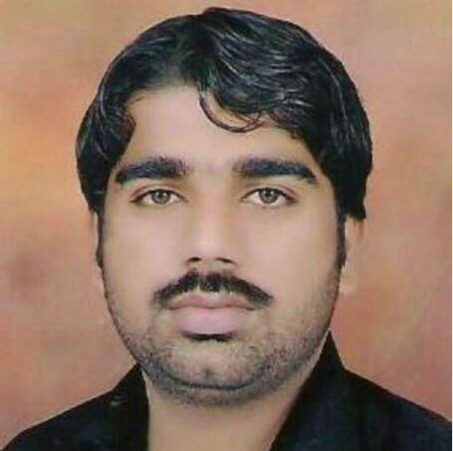
Khurshid Alam
Hassa Kachi Paind Khan Shumali,
Tehsil & District D.I.Khan.
Mobile #: 0092 03439843324
E – Mail Address: alam_karlu@yahoo.com

Career Objectives: | Seeking a challenging and responsible position where my education, abilities and potential can be fully and efficiently utilized, which offers opportunities of growth, to acquire more knowledge and skill, and to utilize my skill to serve in your organization.
Personal Profile: | Father Name Alam Sher  Domicile District D.I.Khan.  Nationality Pakistani  N.I.C No 12101-8127872-5  Postal Address Hassa Kachi Paind Khan Shumali, D.I.Khan,
Education: | - M.Sc. (Economics) 2018  Gomal University 1621/2000  - B.A (Economics) 2014  Gomal University 296/550  - D.A.E (Civil) : 2007  B.T.E, Peshawar  Marks Obtained : 1975/3350  - S.S.C : 2003  B.I.S.E, Bannu  Marks Obtained : 449/850
Additional Qualification | - B.Tech(Civil Engg:) 2013  BZU Multan 913/1400  - B.Ed (Education) 2015  A.I.O.U Islamabad 625/1200  - Diploma of Information Technology (DIT) 2015  B.T.E Peshawar 1096/1400
Working Experience | - Now I am working as a Data UCCO (DSO) with COMNet, in District Emergency Operation Centre D.I.Khan since March 2018.  Major Tasks :  - Support the Risk assessment team for revising and updating List SCORE of UCs  - Support PEI–EPI Synergy focal person in Conducting data analysis on PEI & routine immunization.  - Coordinate implementation of corrective actions in areas/ UCs flagged as high risk or outbreak areas  - On campaign performance trends to identify areas of chronic weakness for corrective action)  - Pre campaign-readiness report  - Intra-campaign-daily day wise analytical report  - Post campaign reports  - Follow - up with UC staff for submission of data for reports.  - Monitor and follow-up with UC staff on regular data upload on polio info database.  - Maintain datasets of COMNet UCs in the whole District .  - UC level data collection and compilation on key indicators to generate pre, intra and post campaign report.  - Collate and analyse campaign data, monitor feedback from UCOs and generate daily CCPV, COMNet monitoring updates during campaigns.  - Guide and on job train CCPV and COMNet staff on reporting tools.  - Analyse data of dashboard indicators with UC wise feedback to the UCO and SMs.  - Maintain close liaison with DPCR data operator for two way data flow.  - To work as focal person for DSC correspondence and follow-up with field staff.  - Collection of data for campaign planning from UC level for onward submission.  - Maintain the data of social characteristics of polio cases of the respective district.  - Worked as a Data TTM (WHO) in District Polio Control Room DIKhan w.e.f September 2015 – February 2018.  - IDIMS (Polio)  - IDIMS- Surveillance  - EOC Dashboard  - DDM (Direct Disbursement Mechanism) Software  - 6 months Worked as a Data Verification Supervisor in CHIP Training & Consulting pvt Ltd (UNICEF) Project D.I.Khan.  - 2 years Worked as a Data Entry Operator in Irrigation Department FATA Secretariat Peshawar with Specially (FIMS) Software.  - 6 months Worked as a Data Entry Operator in NADRA Department (SCAC PROJECT) D.I.Khan Project in 2010-2011.  - 6 months worked with IKF & MKR Organization Pvt Ltd as a  Data Collector in Flood 2010 District D.I.Khan.  - 5 years working experience in Karlu Computer & Composing Centre D.I.Khan as a Professional Designer.
Technical Skills: | - Tablue Data Software , Power Bi,  - Full Command on MS Power Point, Word, Excel, Inpage, Coral Draw, Auto Cad, Adobe Photoshop etc.  - I have got 1st Position in Whole Province K.P.K in Nadra Typing Test in 2011.
Trainings | - I have Done Different Trainings on  - IDIMS Software from EOC Khyber Pakhtunkhwa  - IDIMS Surveillance from EOC Khyber Pakhtunkhwa.  - Data Focal Person for MEASLES campaign November 2021 in EPI KP.  - fIPV Campaign August 2022
Languages Ability | - English  - Urdu  - Saraiki  - Pashto

