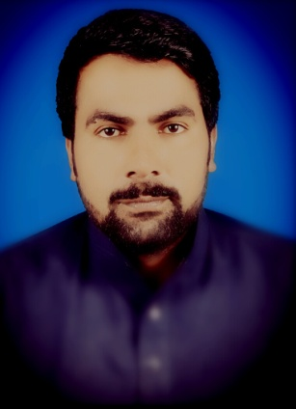

##### *URRICULUM*

***ITAE***

###### AHSAN ULLAH

***Permanent Address 78 /15.L post office same Khanewal***

**(Punjab) Pakistan**

***Cell #*  +92300-7847374/03461014922**

***Apply position : Apply for Monitoring &Eval Evaluation officer.***

## OBJECTIVE:

* To pursue attractive executive position in an esteemed organization offering career opportunities and allowing me to make significant contribution towards its success.

## PERSONAL INFORMATION:

Father’s Name Mehr Din

Date of Birth 10-04-1984

C.N.I.C. # 36104-7946457-3

Nationality Pakistani

Religion Islam

Marital Status Married

Gender Male

Domicile Khanewal (Punjab)

Email rehanghazi784@gmail.com

## QUALIFICATION:

|  |  |  |  |
| --- | --- | --- | --- |
| **Degree** | **Passing Years** | **Marks/CGPA** | **Board/University** |
| **Matric**  F.A  B.A  PGD( C/Science)  B.Ed  MA Pak studies  MA English | 2001  2003  2005  2007  2013  2011  2013 | 466/850  601/1100  500/800  900/1200  2323/3100  457/1000  1213/1700 | BISE Multan  BISE Multan  BZU MMultan  PITB Lahore  UOE Lahore  BZU multan  UOE Lahore |

## LANGUAGES:

* Urdu
* Punjabi
* English

## Experience :

5 years working as Monitoring officer/Reporting officer in NRSP projects Development, Education , Community Health services etc.Thevmain objective of job is monitor the project tasks & project based activities.Timely arranged the daily basis field visit,deeply observed the activities of field worker's in the field compare the field activities with the project goal than prepared a good and reliable report for the senior.always work the coordination of field worker's and other stake holders.Fully focused on the project goal and seniors instructions etc.

1 year working as project coordinator in sathi foundation.Creat a good coordination among the team worker's and stake holders,community etc.Timely fullfil the project tasks and timely reported to the senior management.

1 year working as BAT(Business Acceleration Trainer) in kashf foundation GAC project in GESA (Gender improvement & social advocasy) department. Timely conduct the training and achieved target's on proper fix tenure.Work with the coordination of the Operation staff and higher management.Achieved good & excellent remarks in Compliance &Head office monitoring in the field.Timely uploaded all training history (sessions) on MIS system.Recently get Star performance certificate from GESA department in Multan region.