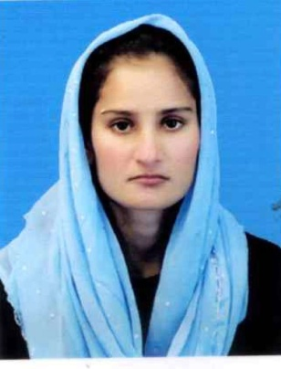



## 

## Cell No: +923146222056

Address: MUHALLA PURANI BASTI TILKOT MUZAFFARGAR.

----------------------------------------------------------------------------------------------------------------------------------

# CAREER OBJECTIVE:

To become a part of dynamic organization where I can utilize my diversified knowledge for the continuous perfection of the organization as well as my personal growth.

# PERSONAL PROFILE:  

➲ Father Name : MUHAMMAD IBRAHIM

➲ Date of Birth : 06-03-1999

➲ Marital Status : Single

➲ Religion : Islam

➲ Gender : FEMALE

➲ Domicile : MUZAFFARGARH (Punjab)

# EDUCATION:

|  |  |  |  |
| --- | --- | --- | --- |
| **Degree** | **Year** | **Division** | **Board/University** |
| **Matric** | **2015** | **2nd** | **BISE DG KHAN** |
| **FSC** | **2018** | **2nd** | **BISE DG KHAN** |
| **BS(ENG)** | **2022** | **Continue** | **BZU Multan** |

**Experience:**

➲ 06 Month Experience as a Teacher in madina Tul Ilam Muzaffargarh.

➲ 03 month marketing experience in a kk mart Herbion brand.

➲ 06 month accounting officer training in social security hospital multan.

# Computer Skills:

➲ MS Office

➲ Urdu In page

➲ Internet/E-mail

➲ Window Installation

# LANGUAGES:

➲ English (Read , Write and Speak)

➲ Urdu (Read , Write and Speak)

# REFRENCES:

➲ To be furnished upon required.