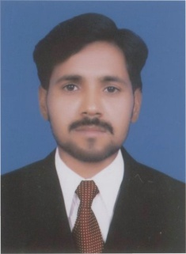**CURRICULUM VITAE**

**PERSONAL PROFILE::**

Name : Saeed Akhtar Qurashi

Father’s Name : Aqil Mahmood Hassan

Date of Birth : 13th July, 1987

NIC No. : 38403-7331374-9

Marital Status : Married

Religion : Islam

Nationality : Pakistani

Domicile : Sargodha (Punjab)

Address : House # 2, Street # 8, Jinnah Colony, Sargodha.

Cell # : 0301-5810007

**ACADEMIC QUALIFICATION::**

B.A Punjab University of Lahore, Pakistan 2006

F.A Govt. A.M.C Sargodha, Pakistan 2002

Matric Govt. Central Model School, Sargodha 1999

**OTHER DETAIL::**

**Computer Diploma:**

* 6-Months diploma in computer and typing Skills, with typing speed 28W/PM, Windows 98-2000, Office 2000.

**WORKING EXPERIENCE ::**

* Worked as a S.S.P.O in Global Pharmaceutical Since July 2009 to June 2012.
* Worked as a P.S in Amarant Pharmaceutical Since June 2012 to 2016.
* Worked as SSPO in Bosch Pakistan (galaxy ) since August 2016 to Dec 2018 .
* Working As ASM In Progressive Health Care Pharma Pakistan Since Jan 2019 to Till Date .

**REFERENCES::**

* References will be furnished on your demand.