CURRICULUM VITAE
URRICULUM
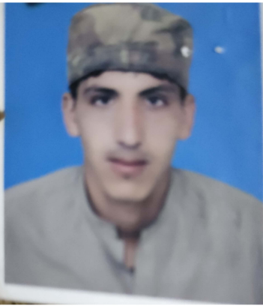

URRICULUM

ITAE

Name : MUHAMMAD MASAB

QUALIFICATIONS
Name : MUHAMMAD MASAB
Father Name : MUHAMMAD ISMAIL KHAN
Date of Birth : 11 Apr-1992
Nationality : Pakistani
CNIC# : 12102-2131238-9
Domicile : Dera Ismail Khan (Khyber Pakhtunkhwa)
Religion : Islam
Marital Status : Single
Languages : Urdu, Pashto, English

EXAM | MARKS | %AGE | YEAR | BOARD/UNIVERSITY | SUBJECT  MAILING ADDRESS  Mohallah Burzu khail House no735/83 post office, Daraban Kalan  (D.I.Khan)  HOBBIES  PLAYING & Watching Cricket  Contact No:  0342-9830864
S.S.C | 485/900 | 53 | 2008 | B.I.S.E D.I.Khan | Physics, Math,  Computer
DEA | 2097/3550 | 60 | 2011 | BTE Peshawar
B.A | 282/550 | 51 | 2013 | Gomal University D.I.Khan | English, Urdu, Islamiat
M.A | 522/1100 | 47 | 2015 | Gomal University D.I.Khan | Islamiat

gg

Expert in MS Office (Word , Excel , Etc )

PERSONAL DATA
Experience Five Years experience in Polio.

Language
Urdu English
Pashto Saraiki

