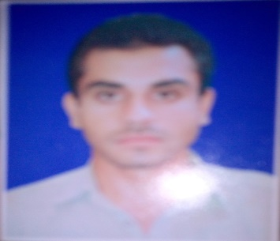***MUHAMMAD TARIQ***

***Contact information and Address :* Musa zai sharif Tehsil: Daraban kalan District: Dera Ismail khan Contact**:**0346-8863159**

**Email***:* [*suhaibhassan863@gmail.com*](mailto:suhaibhassan863@gmail.com)

***Career Information***

**To work in an environment whereappreciations furnish my skill and progress of the corporate values my appreciation .the company objective is my objective .flexibility of adopting different environment uplift me to take any challenges**.

***Personal Information***

* **Father name: Abdul Ghafar**
* **Date of birth: 15-04-1995**
* **C.N.I.C: 12104-6494751-7**
* **Domicil: Dera Ismail khan**
* **Religion: Islam**
* **Marital status:  *Married***
* **Nationality : *P*akistani**

***Academic Qualification***

|  |  |  |  |
| --- | --- | --- | --- |
| **Degree Title** | **Year** | **Marks** | **Board/University** |
| **S.S.C** | **2013** | **506/1050** | **B.I.S.E DIK** |
| **H.S.S.C** | **2016** | **465/1100** | **B.I.S.E DIK** |
| **B.A**  **MA** | **2018**  **2021** | **270/550**  **665/1100** | **Gomal University**  **Gomal University** |

***Experience:***

* **COMPLIANCE MONITOR** 01-Aug-2018 To 31-March-2020 in **SRSP.**
* Work as Team leader in **POLIO/EPI** program in **UNION COUNCIL BUKHI** Child Data collection & cluster Door to Door visit **2014 to Till Now**.
* Worked as a MT Mufti Mehmood Hospital.

***Language*** *Urdu ,English,Pashtu,Saraiki*

***Reference:***

**Will be provided at Request**