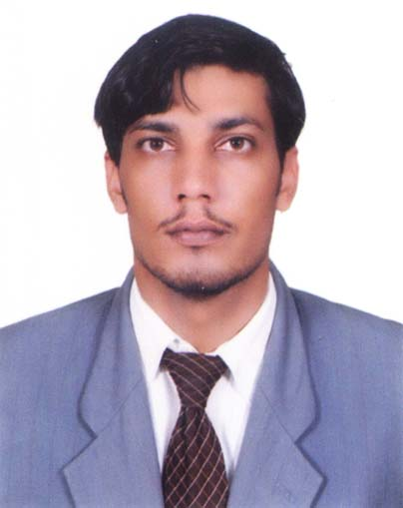

Mehtab Ahmad
Address: Mohallah Faizabad, Teh Daraban Kalan, Distt. D.I Khan

Cell: 0346-7878812
E-mail. mehtabahmad.khan@yahoo.com
   

Personal Statement

I am looking for an environment where I may apply and utilize my knowledge to the best of my abilities for learning more in the related field of development and growth of my professional career on the basis of sincerity, honor regularity and hardworking.

Personal Information

Father Name : Abdur Razzaq
Date of Birth : 01-01-1987
NIC # : 12104-3957663-1
Religion : Islam
Marital Status : Single
Nationality : Pakistani
Domicile : KPK (D.I. Khan)

Academic Qualifications

- Matric From Bannu Board
- F.A From Bannu Board
- B.A From Gomal University D.I Khan
- M.Sc Economics (Not completed) From Gomal University D.I Khan
- M.A Islamic Studies From Gomal University D.I Khan

Computer & Other Skills

- Basic Computer Course (Word, Excel, Power Point, Internet etc)
- Auto Cad From NLC Institute Dena Jehlum
- Diploma in Information Technology From BTE Peshawar

Working Experience

- 2 years experience as “Project Coordinator” in Karwan NGO Islamabad.
- 1 Years experience as a TSO in Pepsico (Int) Islamabad.
- 4 years experience as a IT Officer in Pepsico (Int) Islamabad.
- 5 months of experience as “Supervisor” in Surjitex Medicine Factory Lahore.
- 1 Year experience in “ Sabayon NGO” as a Public Relation Officer. (D.I.Khan)
- 5 Months experience in Tele Marketing (English Based Call Center)
- 4 years of experience as “Teacher” in Oxford High School D.I Khan.

Language

- Urdu, English, Pashto, Punjabi, Saraiki

- Furnished Upon Request

References

