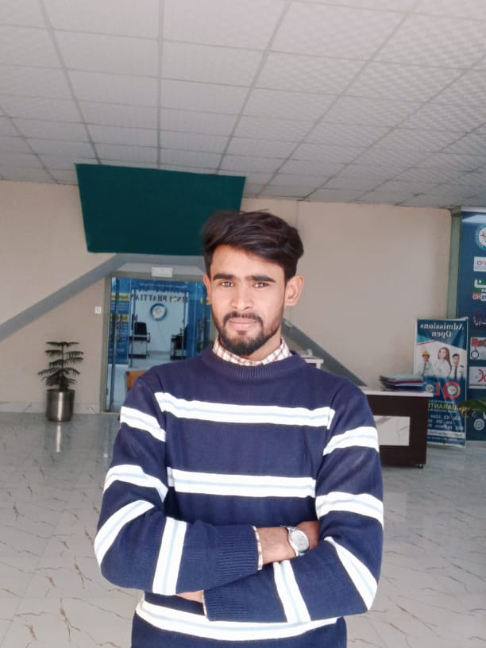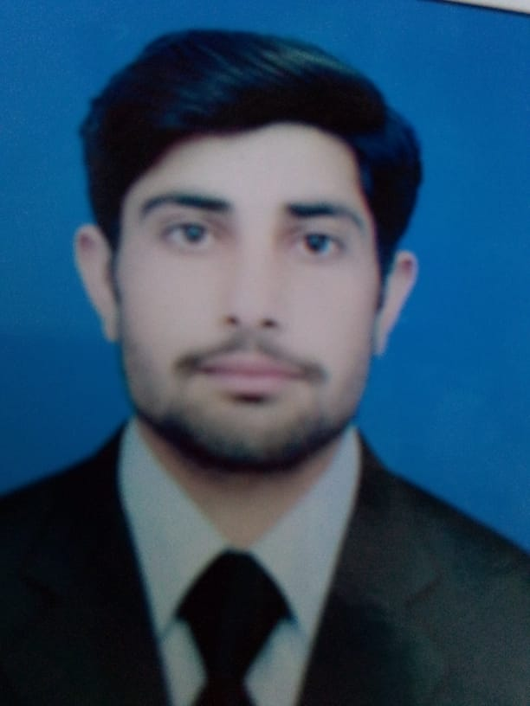

Saleem Bashir

ABOUT ME

I am a person who is positive about

aspect of life. I am a hardworking, energetic, devoting, confident, & a social person. I always like to perform the given task to the perfection.

DOB: 07-03-2000

CNIC: 34302-3814364-3

Religion: **Islam**

Marital Status: **Single**

CONTACT ME

Address

Village Fatehki Tehsil Pindi Bhattian district Hafizabad

Cell: 0300-0028322

Email: saleembashir81@gmail.com

MY SKILLS

MS Office

Filmore X

INTERESTS

Gaming

Movies

Swimming

Travelling

Cricket

EDUCATION

WORK EXPERIENCE

ACHIEVEMENTS

* Master In Urdu

2022

University of Punjab

* BACHELOR OF Arts

2018-2020

University of the Punjab

1 and Half year work experience as State Officer in Private Sector.

* INTERMEDIATE IN FA (D.com)

2016-2018

Govt. Degree College Pindi Bhattian

Nishtar Model High School Pindi Bhattian

* MATRICULATION (SCIENCE)

2014-2016

**OBJECTIVE**

To work in a well reputable organization among best professionals & in a challenging atmosphere that offers enormous chances of growth & further facilitate my ability to help the organization to reach its strategic goals.

* Got Education Scholarship from Govt. degree Colleges in during Intermediate.
* Got Free Education Scholarship from Govt. Degree college for Bachelor.
* Various Certificates & Prizes for best performances in class exams.

LANGUAGES

* English
* Urdu
* Punjabi

REFERENCES

Will be furnished on demand.

