SHAFQAT ALI

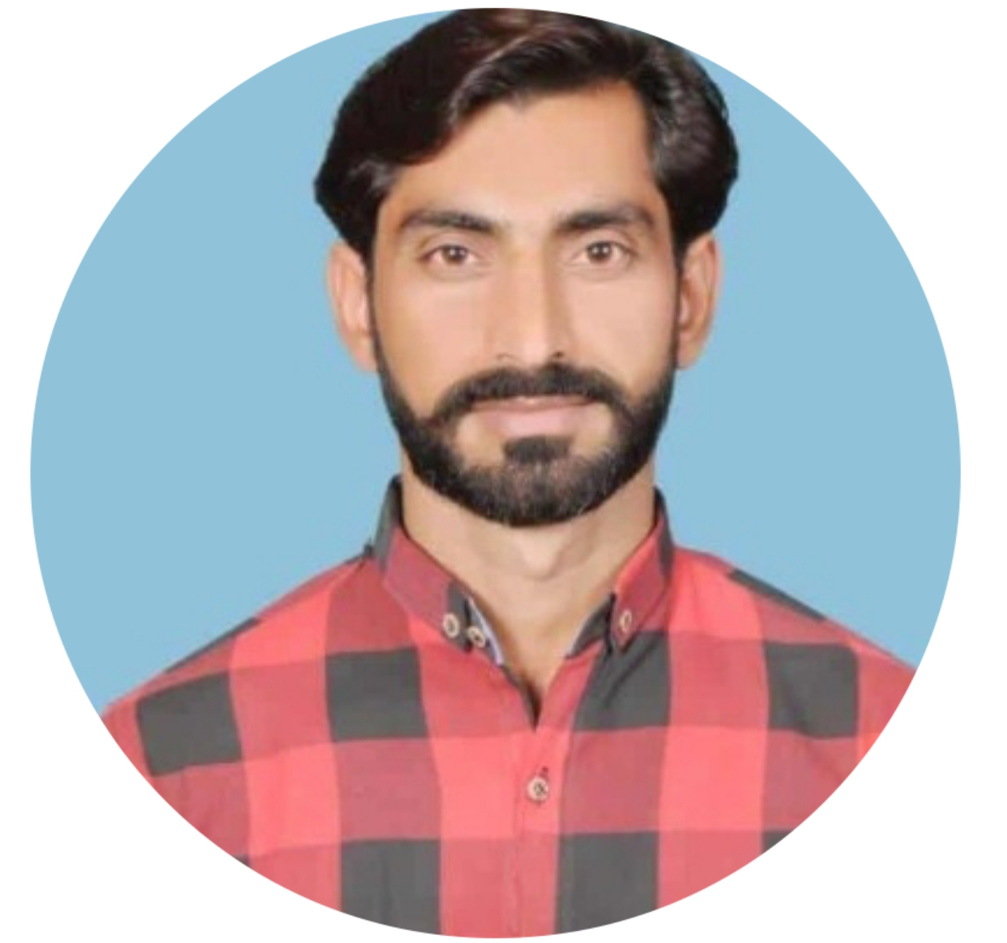

Phone: (+92) 345-8968904

E-Mail: shafqatali786.sh@gmail

# Professional Summary

I carry more than five years of working experience across more than 10 Research and development sector projects with diverse experience in leading organizations related to the social and development sector.

Effective organizational, communication and planning skills developed while working in multiple NGOs and organizations. Adaptable and able to quickly establish report with others as evidenced when working in teams both on my course and in work situations

I have working experience with national and international donors such as **WHO, British Council, UNICE, Duke University and BOS.**

Throughout my career, I have been involved in fields like Monitoring and Evaluation, Field work, Qualitative and Quantitative data collection. Team Management, Data Management.

# SOFTWARE TOOLS

* Efficient in MS Office (Excel, Word, Power Point),
* Open Data Kit (ODK) -Android based data collection tool
* Survey CTO (Android based data collection),
* Basic computer applications.
* CRM(Customer Relationship Management) System (Like Oracle, Microsoft Dynamic etc.)

**EDUCATION**

|  |  |  |
| --- | --- | --- |
| **Degree/Certificate** | **Institute** | **Year of Completion** |
| Graduation | AIOU | 2021 |

# WORK EXPERIENCE

* **Organization: Contech international**
* **Project:** PPIF-II (Family Planning)
* **Designation**: District Coordinator(Sheikhupura)
* **Organization: Contech international**
* **Project: PPIF-1** (Family Planning)
* **Designation**: District Coordinator (Sheikhupura)
* **Organization: Phoenix Foundation For Research & Development**
* **Project:** Mental health and Wellbeing in Pakistan
* **Designation:** Supervisor (Sheikhupura)
* **Organization: British Council**
* **Project:** Different Exams like O-Level A-Level
* **Designation:** Invigilator (Sheikhupura)

* **Organization: The Initiative**
* **Project:** STOP 2(Research on Smoking)
* **Designation:** Field Researcher (Faisalabad)
* **Organization: Tameer-E-Khalaq Foundation**
* **Project:** Measles & Rubella Vaccination
* **Designation:** Monitoring Evaluation (Gujranwala)

* **Organization: SDPI (Sustainable development Policy Institute)**
* **Project:** Citizens Perception Index Survey (phase 2)
* **Designation:** Enumerator (Sheikhupura)

* **Organization: PHC Global**
* **Project:** Typhoid Conjugate Vaccine
* **Designation:** Research Associate (Sheikhupura)
* **Organization: SDPI(Sustainable development Policy Institute)**
* **Project:** Citizens Perception Index Survey(Panel Study phase 1)
* **Designation:** Enumerator (Sheikhupura)
* **Organization: APEX Consulting Pakistan**
* **Project:** LQAS(Lot Quality Assurance Sampling)
* **Designation:** Area Field Officer (Sheikhupura)
* **From 2017 to 2021**
* Major Responsibilities:
* Arrangements of logistics
* Area identification
* Plane Making
* Team Leading
* **Organization: Apex Consulting Pakistan**
* **Project:** Women Empowerment
* **Designation:** Enumerator (Sheikhupura)
* **Organization: The AC Nielsen**
* **Project:** Immunization
* **Designation:** Lister & Mapper (Lahore, Nankana Sahib)
* **LANGUAGE**
* English, Urdu, Punjabi