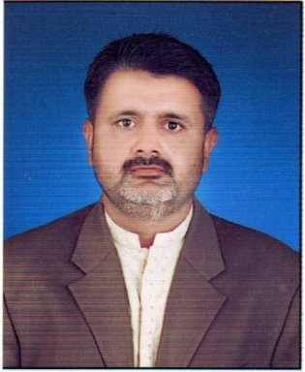  
***CAREER OBJECTIVE:***

saddam hussain channa

**Address:**Q NO: F13 Scarap irrigation colony near IBA Public School military road Sukkur

[Saddamchanna7](mailto:saddamchanna7@gmail.com)[@gmail.com](mailto:7@gmail.com)

Cell: 0312-3488533

Seeking for job related to my qualification I performance oriented organization and to become an active part on an organization that offers a challenging position in a good working environment where I can share my professional qualification, knowledge, skills and ability.

***PERSONAL INFORMATION:***

* Fathers Name : Muhammad Siddique
* Date of Birth : 15-08-1994
* Domicile/PRC : Shikarpur (Rural)
* Nationality : Pakistani
* Religion : Islam
* Marital Status : Single

***ACADEMIC QUALIFICATION***

|  |
| --- |
| Degree / Certificate |
| 1. B.SC: Engineering 2014 To 2015 from Shah Abdul Latif University Khairpur. 2. Intermediate: Pre Engineering 2010 To 2012 From Govt: Boys Degree Collage Sukkur. 3. Matriculation: Science 2005 to 2010 From Govt: Boys Double Section High School Birrage Road Sukkur. |

***EXPERIENCE***

* 7Month Experience as a T.M at Nexcon Pharmaceutical (Feb to August 2022)

Roll: promoting and sell company's products, whether that's pharmaceutical drugs

(Group gainy)

Salary Pkage RS: 40.000

* 02 Years’ Experience as a Oder Booker at Mux Food Company All Fayaz Traders.

(2018 To 2020)

Roll: Order booking at mini Distributers Products of chips Nimko

Salary Pkage: RS:18.000+20.000

* 02 Years Experience as a D.S.O at ZONG Franchise Sukkur. (2016 To 2018)

Roll: Direct Sales Marketing Activity Prepaid &Postpaid Sims wifi devices

Salary Pkage: 15.000+3000

***Skills***

* Communication. (Good)
* Social work (Good)
* Marketing (Good)
* Operating system Computer. (Good)

***LANGUAGES***

* Sindhi, Urdu, English.