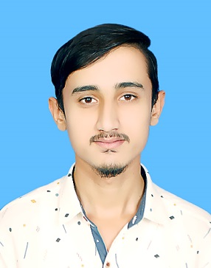

Objective

A highly motivated and deadline-driven engineer with proven leadership capabilities, who likes to take initiative and seek out new challenges and capable of learning from new exposure within the structured framework of the organization.

Skill Highlights

|  |  |
| --- | --- |
| * Strong decision maker * Complex problem solver * Quick Learner * Hard worker * Leadership * MS office | * Innovative * Service-focused * Good Communication skill * CMG simulator(basic) * Teaching |

Experience

FRESHER

Education

INTERMEDIATE:

COLLEGE: SHAH ABDUL LATIF COLLEGE MPS.

% /GRADE: 81/A-1

GRADUATION:

B.E PETROLEUM AND GAS ENGINEERING FROM DAWOOD

UNIVERSITY OF ENGINEERING AND TECHNOLOGY

Jan, 2018 – Dec, 2021 CGPA: 3.75

Certifications

* Certified in Managing safely (Iosh 5.0) Course, Approved and Validated by the “**Institution of Occupational Safety and Health**”.
* Certified in short course, CIT (Registered) from Sardar Yaseen Malik Institute.

OTHERS

* **Treasurer:**

SPE STUDENT CHAPTER-DUET

(Sep 2020-Sep 2021)

*Muhammad Waleed*

(PETROLEUM AND GAS ENGINEER)

Contact

**Address:**

House no. 07 Akhtar Colony, Mirpurkhas.

**Phone:**

0335-3324770

0322-7946134

**Whatsapp Number:**

0335-3324770

**Email:**

[mwaleed0432@gmail.com](mailto:mwaleed0432@gmail.com)

**LinkedIn:**

https://www.linkedin.com/in/muhammad-waleed-7a2a421b5

Languages

* Urdu
* English
* Punjabi

Hobbies

* Writing
* Cricket