**IRSHAD ALI**

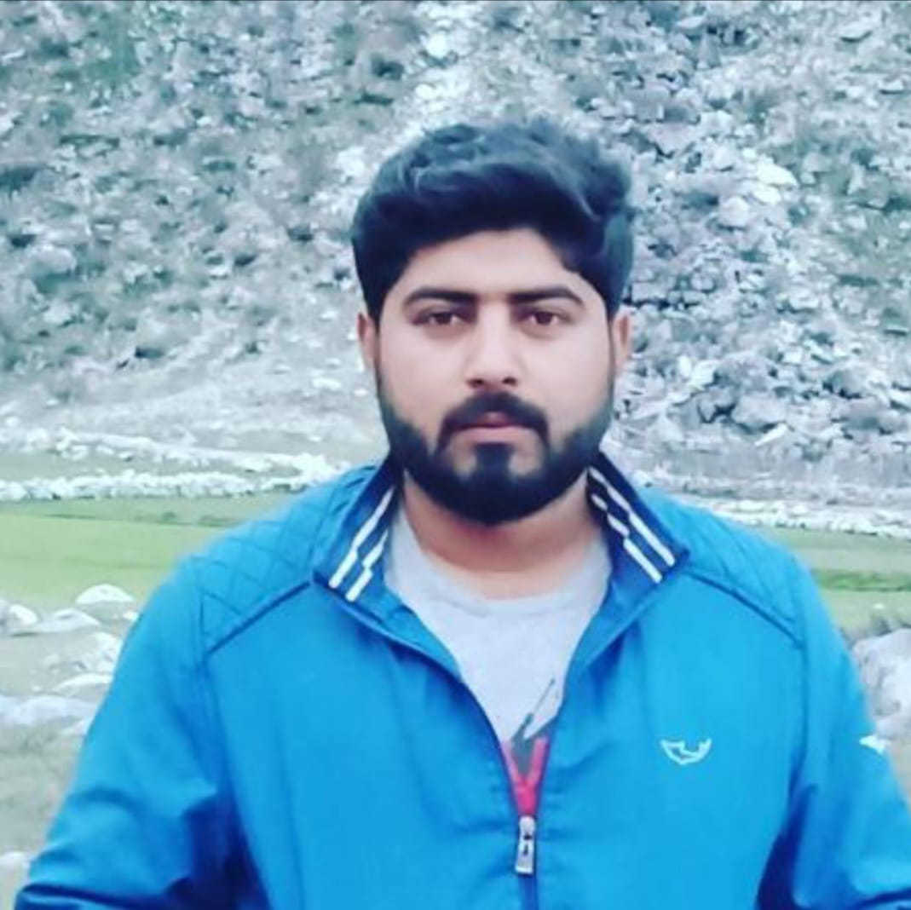

**Contact No :** +**923119433386**

**Email : alee5609@gmail.com**

**Professional Objective:**

* More than Four years working Experience in Telecommunication Field.
* Good experience on Nokia equipment installation and integration,
* Hand on Experience in carrying out Swap Activity ,Testing ,Commissioning and

Troubleshooting on ZTE RBS (W301).

* Experience in operating, maintaining and managing various network elements in Transmission, RBS and Test Gears (Power Meter, OMT, CMD and Site Master BIRD)  
  other basic tools.
* Hand on Experience in Resolving Low TCH, Sector and Partial Swap, DCR and VSWR Issue
* Expert in reforming 1800(2g) to 4g
* Good management skills
* Experience in survey

**Work Experience:**

**RELACOM Pakistan (pvt) Limited (september 2017 upto April 2019)**

**BSS &Microwave Engineer**

**Telenor Zte to Nokia Swap project**

* Know better about Nokia equipment
* Installation of Nokia equipment
* Configuration of Nokia Equipments like FSMF, FPFH ,
* Know about how to add Gps antenna
* Know about Ret configuration
* Nokia survey
* Making As built report
* Doing site with better Qualiy
* Manage the team on better way
* Motivate the team during work on site
* Troubleshooting and maintenance of site
* Know how to change Subnet mask IP
* Know how to install RFM and RRH

**Nokia Mobilink LTE project**

* Install FSMF and upgradation
* Know to integrate FSMF
* Up gradation of mobilink 4g RFM module AREA OR FXED
* Doing DT probe of 4g site
* Supervise complete site
* Know everything about nokia installation and integration

**ZONG Roll Out project**

**ZONG ROLLOUT PROJECT**

* Supervising the Implementation and Cut Over team.
* Supervised all installation indoor and outdoor RRUS, Digital cable, Rectifier and Earthing System
* Ensuring Quality Work at Site
* Performed Several Cutover with minimum outage
* Troubleshoot RBS and Clearing all Alarm.
* External alarm Configuration and verification and troubleshooting
* Check all materials before start installation
* Supervision to do MW dishes panning.
* Ensure the visibility of different Network elements at NOC for efficient operations.
* Dismantling of different links for Re use according to Transmission design.

**TELENOR (LTE+ REFORMING) PROJECT**

* Supervising the SWAP and Microwave team
* ZXSDR8900 and ZXSDR8700 installation
* Site Commissioning (MO File Loading) of SDR through LMT.
* External alarms pitching and verification.
* Can use site master for VSWR results and DTF.
* Hand on experience on W301
* Links installation and commissioning of I-paso link 200,400 and 1000.
* Installation of NEC 0.3, 0.6,1.2 ,1.8 dishes
* Creating V-LAN for Media Transferring
* Commissioning iPaso link for (1+0,1+1) Microwave Link
* Dismantling of Old equipment
* Replace 2g (1800) RRU by (8500) 4g reforming

**Currently I am working in I Engineering as senior technical field officer since 1st jan 2021**

Working with Huawei rectifier (ICC300, ICC500, TP 48200, APM30)

* SMU02, SMU03 version up gradation.
* Huawei Rectifier Alarms configuration and Troubleshooting.
* Preventive Maintenance of Huawei rectifier
* Installation of battery bank (AGM, Lithum)
* Troubleshooting of Neteco Visibility
* Working of Huawei OWS, Mateline, system
* O&M issue end to end Telco + Non-Telco.
* Micro Wave NEC PASOLINK and Huawei RTN M/W installation and alignments.
* Huawei BBU 3900 and 3G/4G installation and ATP.
* Huawei 3G VSWR and RTWF Troubleshooting.
* Preventive Maintenance of 3900 bts and O&M all 3G/4G sectors.
* Alarms troubleshooting ALD Maintenance Link Failure, RET.
* ATP Conduction (BSS, Micro Wave and Civil works.
* Media patching (Micro Wave,OFS,DRS, BSC, BTS)
* XPIC and STM Link
* Site Master for measurements of VSWR
* Experience on commissioning on different types of Huawei rectifiers i.e 1cc500, icc300, Icc 48200
* Working with ZTE rectifier (ZXDU300 ,ZXDUW001, ZXDUW006 )
* CSU 500, CSU 510B, CSU 500A version up gradation.
* ZTE Rectifier Alarms configuration and Troubleshooting.
* Preventive Maintenance of ZTE rectifier
* Installation of battery bank (AGM, Lithum)
* Troubleshooting of RMS Visibility
* Working of ZTE OWS, Mateline, system
* O&M issue end to end Telco + Non-Telco and power
* Micro Wave NEC PASOLINK and Huawei RTN M/W installation and alignments.
* ZTE BBU 8900 and 3G/4G installation and ATP.
* ZTE 3G VSWR and RTWF Troubleshooting.
* Preventive Maintenance of 900 , 1800 ,2100 bts and O&M all 3G/4G sectors.
* Alarms troubleshooting ALD Maintenance Link Failure, RET.
* ATP Conduction (BSS, Micro Wave and Civil works
* Media patching (Micro Wave, OFS,DRS, BSC, BTS)
* XPIC and STM Link
* Site Master for measurements of VSWR
* Experience on commissioning on different types of ZTE rectifiers i.e ZXDUW001 V3 ,ZXDUW006 , ZXDU300

**Good Experience of working on Field**

My main task was operation and troubleshooting of a site

* Has Good Knowledge of working on Huawei and ZTE Equipment

Operation and troubleshooting of BBU and other Equipments

* Has Good Knowledge about WebLCT Software

Using WebLCT for links information and links concerning issues

* Has Good Knowledge about BTSNEM Software

Commissioning of sites and checking External and Environmental Alarms

**Education**

**Bachelor of Electrical (telecommunication) Engineering 2012-2016**

City university of science and information technology peshawar

**PERSONAL INFORMATION**

**Father Name:** Sher ali

**Date of Birth: 10-08-1994**

**Marital Status:** Married

**Nationality:** Pakistani

**CNIC No:** 17101-4078722-5

**Language:** English

**Computer SKILL**

* Worked on NEC **I-Paso link** IP Network
* MS office
* Enable port for ping test
* Adding LAN in new port
* LMT for commissioning of SDR

**REFERENCE**

Should be available on demand.