**KHURRAM younis**

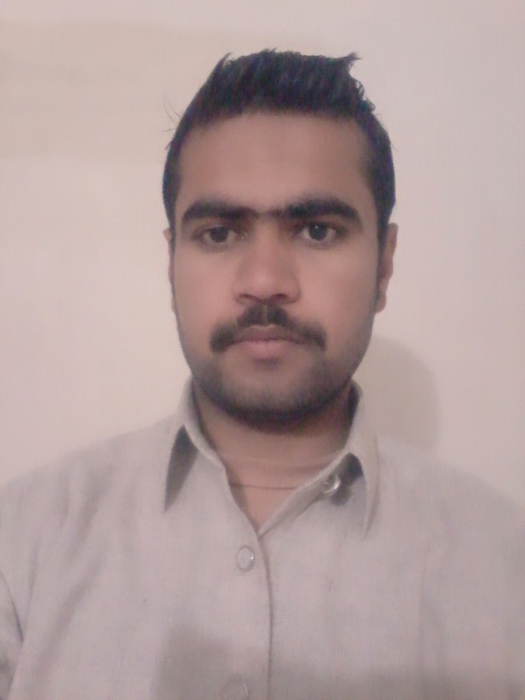

**Contact no: +923439491227**

**+**923155297875

**E-mail Address:** kzada6003@gmail.com

**Address:** House No.101 CBH Mohallah Usman Ghani Havelian

Tehsil Havelian District Abbottabad.

**Objective:**

*A highly motivated individual with well developed skill in the field of civil engineering. sound*

Management skill and implementing new initatives to further organization objectives.

**Personal Information:**

Father’s Name Muhammad Younis

Qualification B-Tech Hon’s (CIVIL) Engineering

Date of Birth 01-01-1993

Religion Islam

Marital Status Single

Nationality Pakistani

N.I.C 13101-0501980-9

Domicile Abbottabad (Khyberpakhtoonkhwa)

Languages known English, Urdu

Passport number RK6909802

Driver license LTV Only

**Qualification:**

|  |  |  |  |  |
| --- | --- | --- | --- | --- |
| **Academic** | **Session** | **Marks/Cgpa** | **Division** | **Board/University** |
| S.S.C | 2010 | 685/1050 | 1ST | BISE ABBOTTABAD |
| D.A.E | 2013 | 2174/3350 | 1st | BTE PESHAWAR |
| B.Tech Hons (civil) Enigineering. | 2017 | 3.11/4.00 | 1st | SARHAD UNIVERSTY PESHAWAR |

Experience:

* Site engineer buildings at M/S Ali Asghar and brothers government contractor in the period of january 2018 to march 2020 at Aust university Havelian Abbottabad .

Other Skills:

* Ielts Academic (International English Language testing system) 5 bands.
* Ms excel , Ms word , powerpoint , Internet.
* Driving license ( Kp Transport Department) LTV Only.
* Autocad {2D, 3D} Six Months COURSE
* Land Survey {six months} Technical and vocational training COURSE KPTTB GOVERNMENT OF KHYBER PAKHTUNKHWA PAKISTAN.
* OSHA (USA) General Industry Safety and Health valid certificate from Cardiff school of certified professionals (CSCP) Abbottabad .
* IOSH (UK) Managing safely institution of Occupational safety and Health in association with Cardiff school of certified professionals (CSCP) Abbottabad.
* Level 2 Award in Fire safety Principles a course approved and validated by the Aosh Awarding Body United Kingdom (uk) in association with Cardiff school of certified professionals (CSCP) Abbottabad.
* NEBOSH (uk) Under construction……
* Registered as Graduate Engineering Technologist from National Technology Council (NTC) Pakistan Registration No:Eng.Tech/CIVIL/03621 and Serial No:G7230.
* 4 Years Experience as a shopkeeper/ Business Marketing like Cosmetics ladies and Gents , Artificial Jewelry ,Garments ladies and Gents ,Crockery etc

**Language:**

* Urdu {Fluent}, English {Fluent}, Hindko {Fluent}