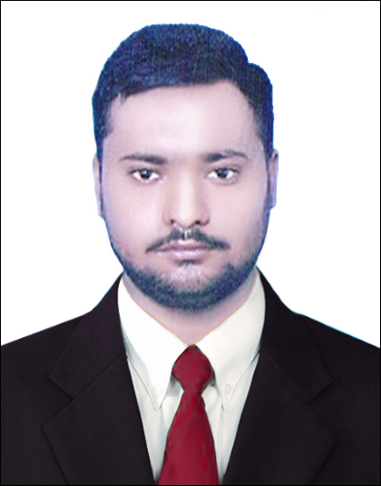**Haider Hafeez Ullah**

+923157437399/+923014811642 ,haider99288@qmail.com

CAREER OBJECTIVE

A challenging position in an organization that involves dedication and commitment helping me to serve it in a professional manner and to develop my career by enhancing skills. Also seeking career advancement in a position in order to assist in ensuring maximum workplace safety and product quality by utilizing extensive experience for optimizing production procedures.

# PROFESSIONAL WORK EXPERIENCE

**Power Plant ( 1235 MW Jhang) (safety officer) 2020-present**

**Pak Arab Refinery Ltd. (Safety officer) 2018-2020**

**Bestway cement industry**

**Responsibilities**

* Conducted tool box on daily basis
* To arrange Third Party Certification of vehicles, equipment’s and machinery.
* To ensure Compliance of work permit on all sites.
* To conduct safety training of worker at work place.
* Report all near miss and incident to HSE lead on daily basis.
* Report HSE observations to HSE lead.
* Supervision of all critical activities (hot work ,work at height ,confine space)
* Conduct safety round of all work site

# EDUCATIONAL BACKGROUND

|  |  |  |
| --- | --- | --- |
| **Degree** | **Institute/Board** | **Marks/CGPA** |
| MSC IR | Institute of Southern Punjab | 2.59 CGPA |
| **FSC (Pre Engineering)** | B.I.S.E Faisalabad | 55% |
| **Matriculation** | B.I.S.E Faisalabad | 60% |

# HSE CERTIFICATES

* NEBOSH International General Certificate.

|  |
| --- |
|  |
| **PROFESSIONAL COURSE** |

* Safety, Training, Observation, Program (STOP) of DUPONT.
* Process Safety and Risk Management Model (PSM) of DUPONT.

* Permit to Work (PTW)

# CARRER SKILLS

* Art Of Presentation Skill By Javid Rising Star
* Youth Engagement Fellowship
* One-month flagship program: September 2019" Investing 66 hours in order to learn personality development, EntrepreneurshEFERENCE

# 

